Families, Births and Children
Births
In 2019/20, 2,196 births were recorded in Greater Dandenong, representing a rise of 41% or 464 since 2001, though a decline from the previous year. The future population of children may not be foreseen with certainty and will depend largely on the rate and level of new housing developments in the city – which tend to attract young families.
Annual Births: Greater Dandenong, 2001-2020
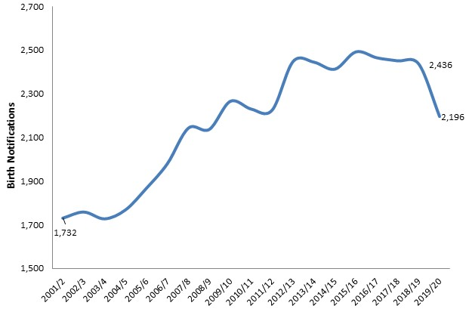
.

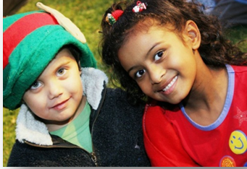

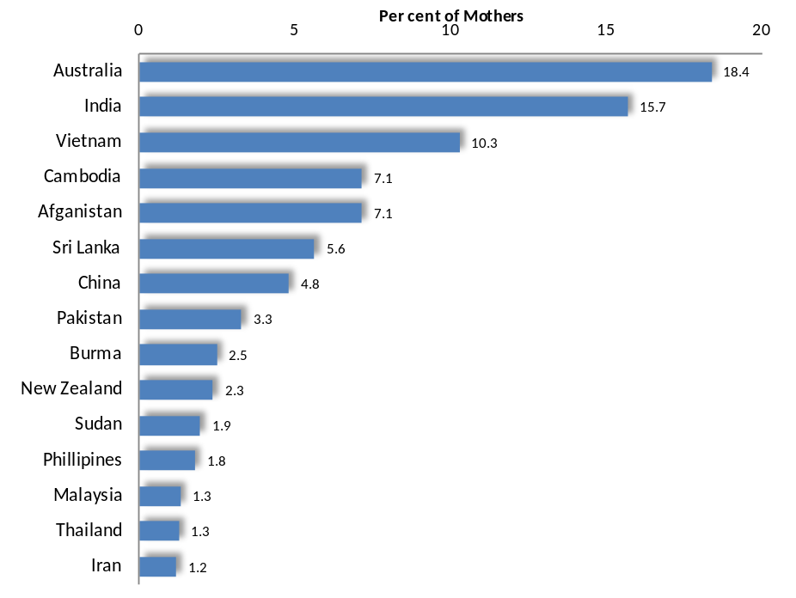
Maternal Birthplaces: Greater Dandenong 2014/15
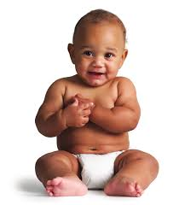
More than four-fifths (82%) of residents who gave birth in 2014/15 (the latest year for which these data are available) were born overseas. Among their birthplaces were India, Vietnam, Sri Lanka, Cambodia, Afghanistan and China – which together account for just over half of these maternal birthplaces.
A selection of birthplaces is presented at right.
In addition, almost three-quarters (71%) of the women who gave birth in 2014/15 speak languages other than English in their homes, including Vietnamese, Punjabi, Khmer, Dari, Kaswahilli and Mandarin.

Birth Rates Age-specific Birth Rates: Australia, 1925-2018
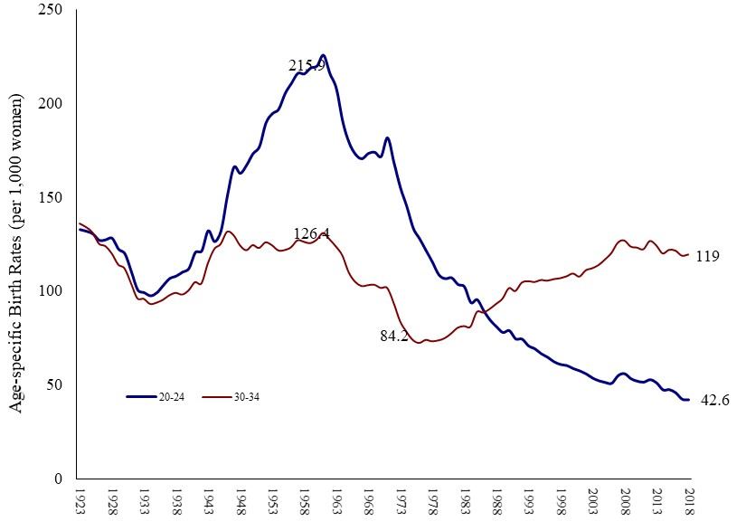
Birth rates have fluctuated widely in Australia during the past ninety years. Rates among 20-24 year-olds rose to a peak of 216 per 1,000 women in 1961, before declining to 46 per 1,000 by 2018. Among women aged 30-34 years on the other hand, rates fell during the depression, rose after the war, declined with the advent of the contraceptive pill and rising levels of labour force participation in the 1960s, before commencing a gradual rise in 1981, which has stabilised in recent years (diagram above).
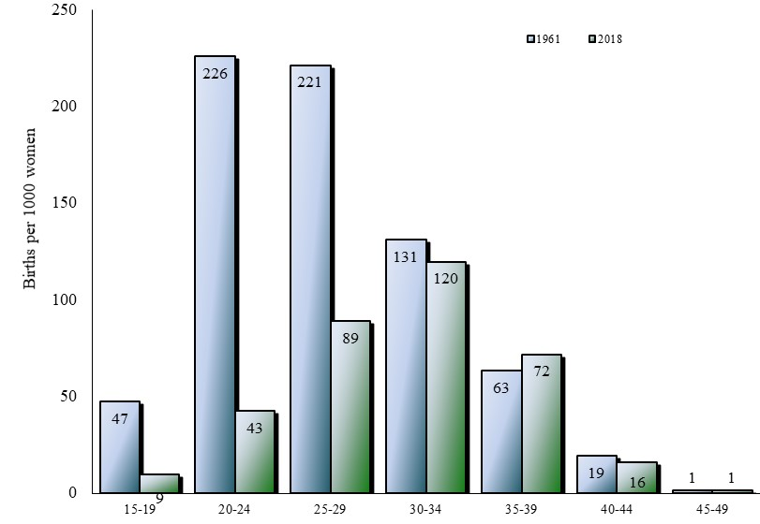
The diagram at left shows the overall change in birth rates among Australian women of each age range, between 1922 and 2018. Most pronounced are the declines in rates among women aged 15 to 29 years. Rates among older women though, have changed little, as the increasing tendency to postpone childbirth has balanced the overall reduction in birth rates.

Birth rates by age: Greater Dandenong and Melbourne, 2018
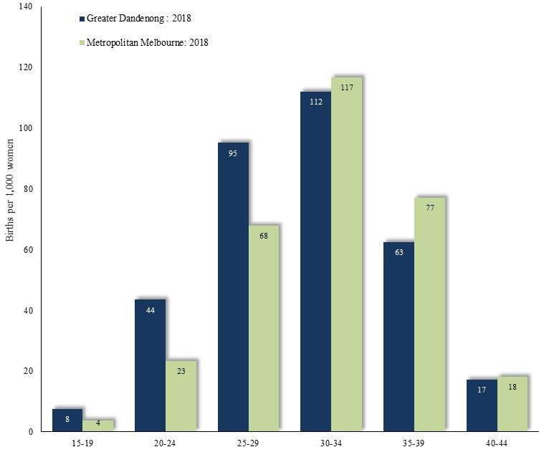
In 2018, birth rates were higher among women aged 15-29 in Greater Dandenong than for Melbourne, and lower among women over 30 – a circumstance common in localities of social disadvantage. The fertility rate in Greater Dandenong [average number of children a woman would have in a lifetime, based on current birth rates], is 1.7 – slightly higher than the metropolitan level of 1.5.

Per cent of Women, who bore five or more Children,
Fertility Rates by Maternal Year of Birth: Australia
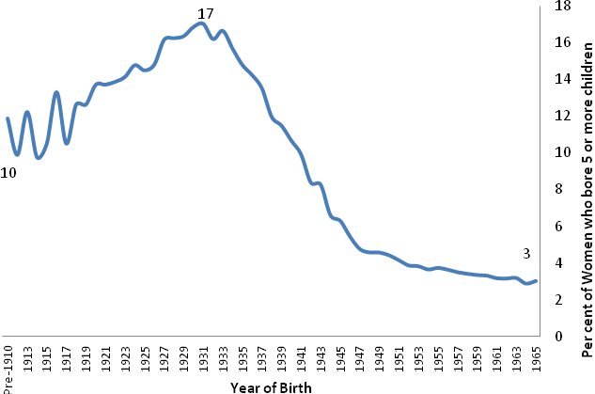
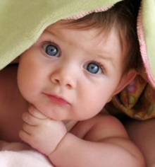
The Australian fertility rate has changed markedly over the past few generations. Among women born before 1910, the average number of children ever born was 2.3, compared with 3.1 among those born to women in the early 1930s, and 2 among those born in the mid-1960s. These trends are more starkly depicted in the proportion of women who gave birth to five or more children, which surged from 10% of women born before 1910, to 17% among women born in 1930, before plunging to 3% among women born in the mid-1960s. (illustration above)

Average Children ever Born by Age and Education Level:
Circumstances which Influence Birth Rates Victoria, 2016
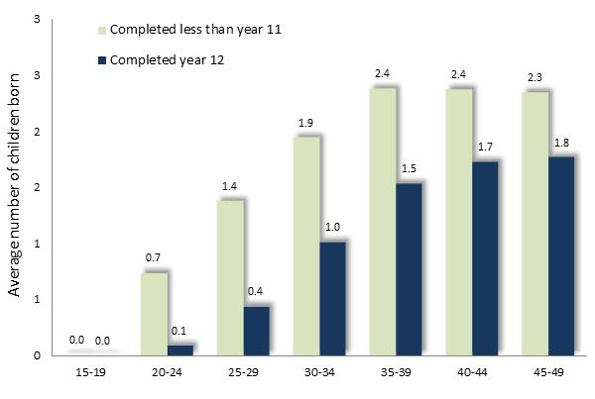
Fertility rates are influenced by educational experience, birthplace and generational factors. Across Victoria, the average number of children ever born to women rises most steeply with age among those with limited educational attainment. As a result, the average number of children born to 20-24 year-old women who left school before completing year 11 is seven times that for those with competed year 12. These trends are illustrated at right.
Similarly, the 2016 Census findings show that the average number of children ever born to women aged 45-49 years, ranges from 1.5 among those with post-graduate degrees, to 2.1 among those with secondary education only.
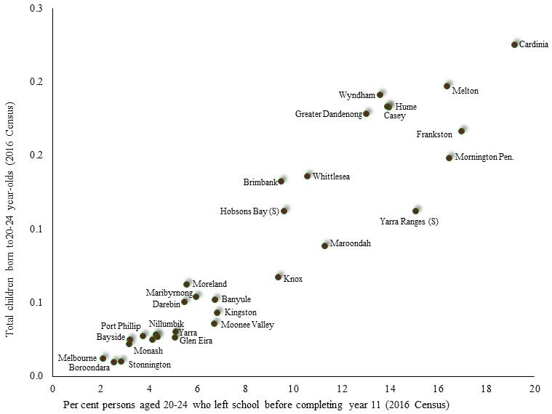
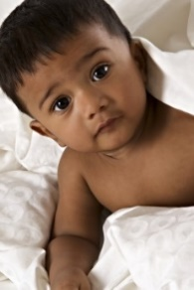
Birth rates among younger women are also strongly influenced by levels of or education. The accompanying diagram illustrates the association between the rate of early school leaving (before completing year 11) among 20-24 year-old women, and the number of children ever born to women of that age, across metropolitan municipalities. These data are drawn from the findings of the 2016 Census.

Correlation between children born per 1,000 women aged 20-24 in 2014, and the percentage of women the same age who had left school before completing year 11 in 2016

Breast Feeding Rates
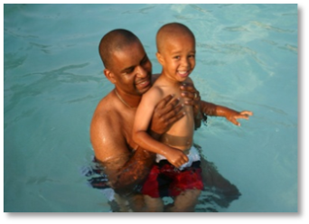
Fifty-five per cent of the women in Greater Dandenong who gave birth in 2014/15 were fully breast feeding at three months – a rate which ranged from two-thirds among women from Bosnia, India, New Zealand, Sri Lanka and Sudan, to less than a third of women born in Australia, Macedonia or Pakistan. By the time their infants had reached 6 months, the proportion of women who were fully breast feeding had declined to 38%. Even so, during the previous 13 years, the proportion of women in Greater Dandenong who fully or partially breast feed at 6 months has risen by 19%.
Among the five most disadvantaged five Victorian municipalities (based on the 2016 SIEFA Index) the average rate of full breast feeding at 3 months in 2015/16 was 45%, compared with 73% among the least disadvantaged municipalities.
Families Family Types: Greater Dandenong, 2016
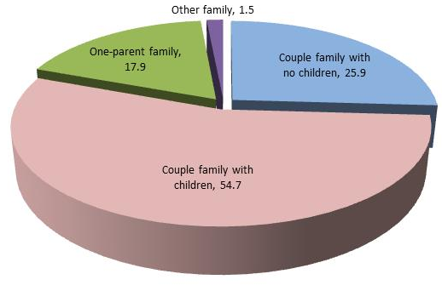
In 2016, there were 38,471 families in Greater Dandenong. Among them, 26% were couples, 55% couples with children, 18% one parent families and the balance, other family types. Over three-quarters of families with children were headed by overseas-born parents – compared with a quarter of families across Victoria.

Geographic Distribution of Family Types
The map below, illustrates variations in the proportion of families with children that are single-parent families. Notably, high proportions of single-parent families are evident in locations within Frankston, Casey, Knox, Maroondah, Hume, Wyndham, Melton and Mornington Peninsula. By contrast, inner-metropolitan municipalities generally feature lower proportions of single-parent families.
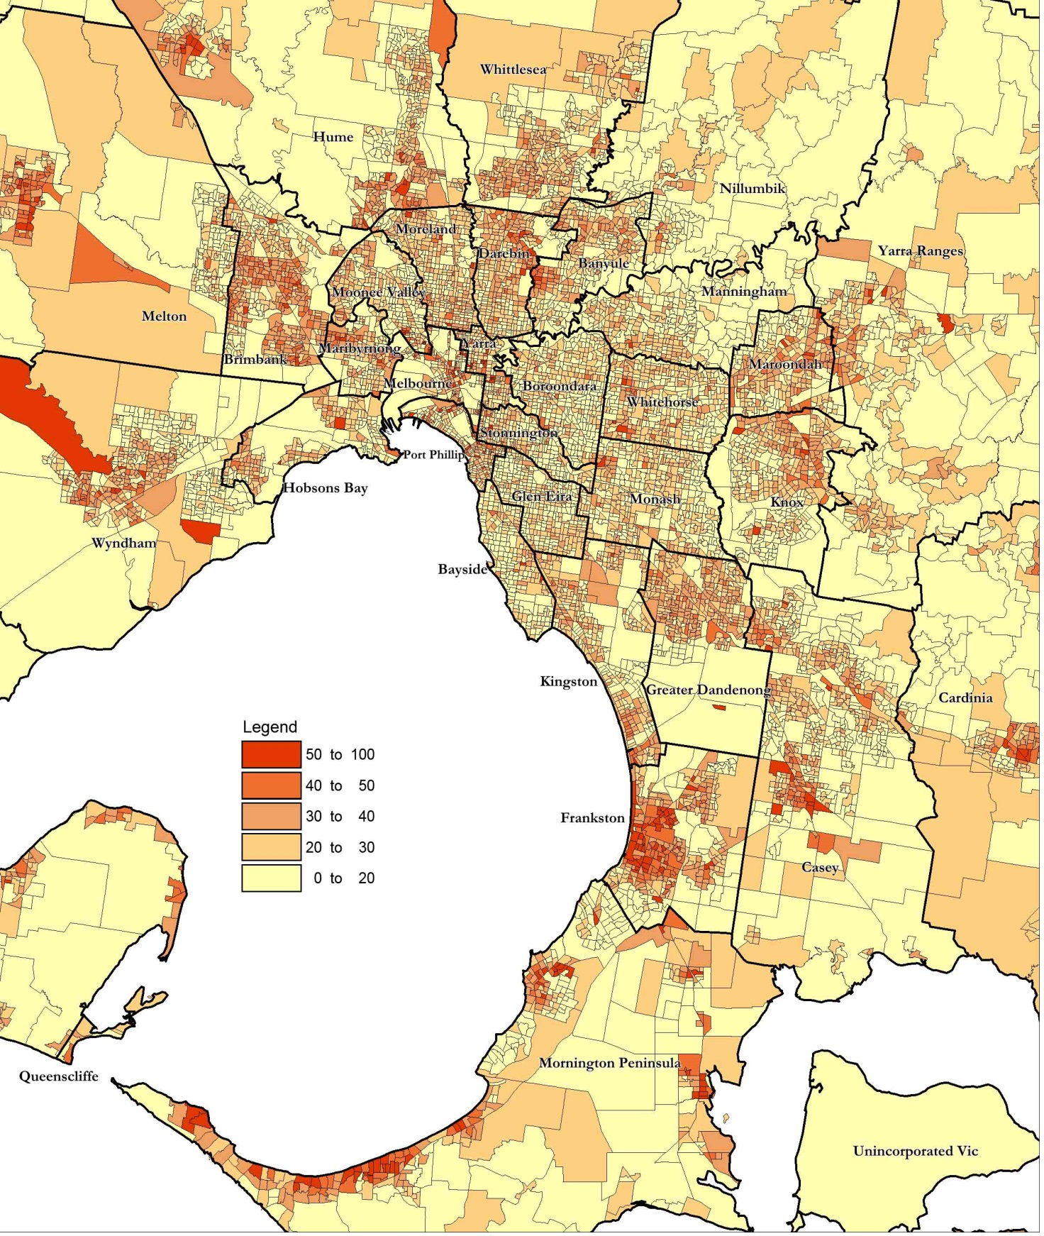
Single-parent Families as a percentage of all Families with Children: Metropolitan Melbourne, 2016

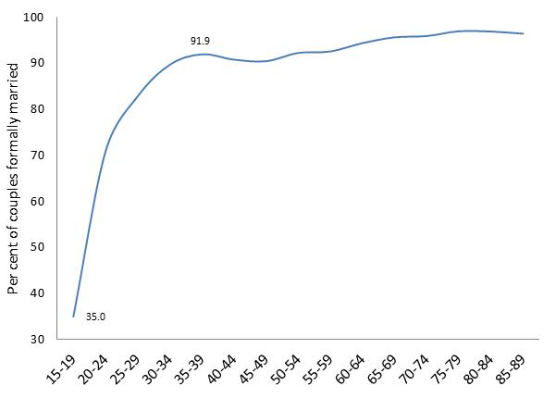
Marriage

In 2016, over nine-tenths (91%) of members of couples aged 18 or more in Greater Dandenong, were formally married – a proportion which rose from 71% of couples aged 20-24 years and exceeded 90% of members of couples over 35 (Diagram left).
The propensity of couples to be formally married varies widely among Victorian municipalities, especially among young people. Of 20-24 year olds in couple relationships, the proportion that are formally married descends from 71% in Greater Dandenong to 13% in Stonnington, 11% in Yarra and none in Murrindindi or Mansfield.
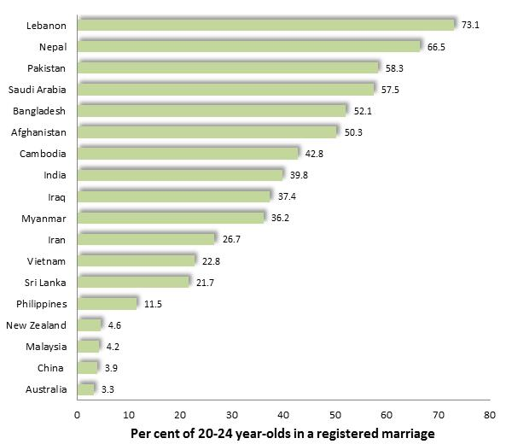

Per cent of 20-24 year-old women in formal marriages, by selected birthplaces: Greater Dandenong, 2016

The 2016 Census found that formal marriage in Greater Dandenong among young adults is most common among residents from Lebanon, Nepal, Pakistan, Bangladesh and Afghanistan. Over half of 20-24 year-old women from these countries are married, compared with 3% of Australian-born women of the same age (diagram right)
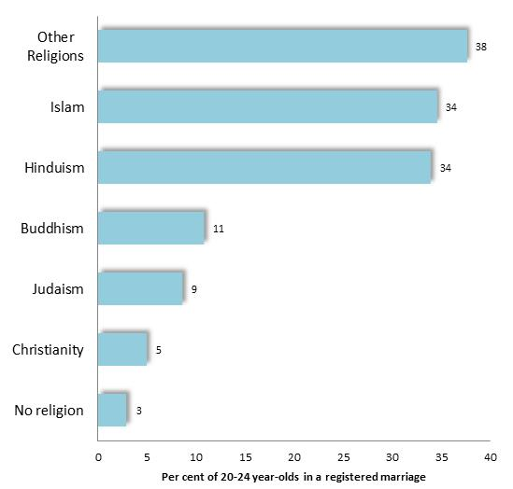

Per cent of 20-24 year-old women in formal marriages, by selected birthplaces: Greater Dandenong, 2016

Religion also exerts an influence upon patterns of marriage. Among 20-24 year-old women in Greater Dandenong, approximately one-third of those who adhere to Islam and Hinduism were formally married in 2016, compared with fewer than 10% of those who follow Christianity, Judaism or who have no religion. Educational attainment also plays a role in these trends: among 20-24 year-old women of various religious faiths, those with less than year 11 education are more likely to be formally married than those who had completed year 11 or more. (below)

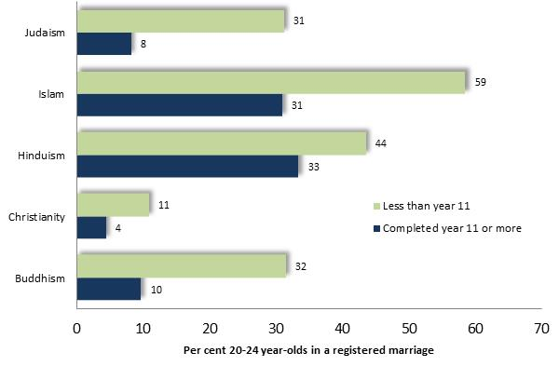

Per cent of 20-24 year-old women in formal marriages, by religion and educational attainment: Greater Dandenong, 2016
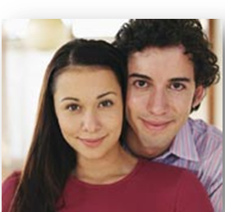

In 2016, 12% of young women in Greater Dandenong who had completed year 11 were married, compared with 24% of those who had left school before completing year 11.
Living Together Before Marriage,
De facto Marriages by Year of Marriage: Australia, 1975-2018
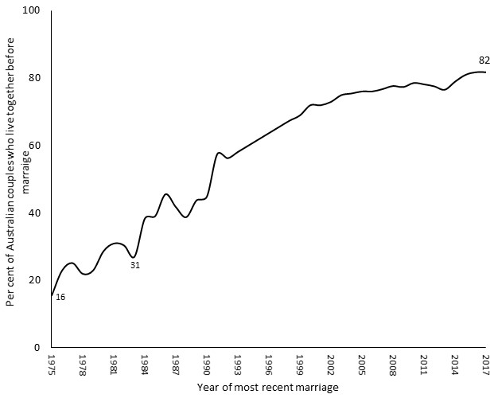
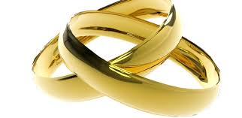
The popularity of de facto marriages has increased markedly during the past few decades, with the proportion of Australian couples who live together before becoming formally married rising from 16% in 1975, to 82% in 2017.

Other Marriage Trends
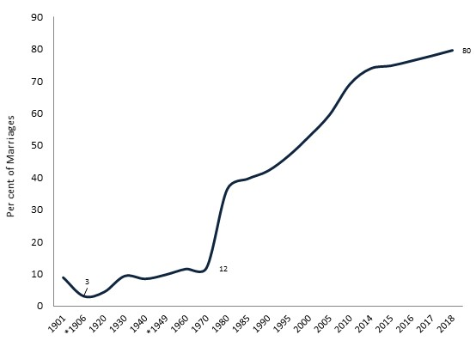
Across Australia, people marry less often and later in life than in the past, with the proportion of people who are married declining by nine-tenths among teenagers, and by nearly four-fifths among young adults, since the mid-1970s.

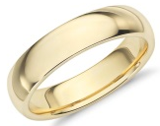
Per cent of marriages presided over by a civil celebrant: Australia, 1901 to 2018

Meantime, the influence of tradition upon marriage has eased, with the proportion of marriages presided over by a civil celebrant rising from 3% in 1906, to 10% by 1960, before surging to 80% by 2018.

Forced Marriage
Forced marriage occurs where one or both parties do not freely consent to the marriage, but are forced or deceived into participation, due to physical, psychological, financial emotional or other pressures. Compliance may be eacted through emotional pressure; threats to withdraw family support or evict; isolation from family, friends and the community; being held captive; threats of physical harm; and murder.
Young women account for about nine-tenths of victim/survivors of forced marriages and most are relatively young.
Though the United Nations documents child marriage in 126 nations, with rates exceeding 30% in 34 countries, in Australia, most are from countries such as Afghanistan, Pakistan, India, Somalia, Fiji, Bangladesh, Sudan, Turkey, China, and the majority are Muslims.
Such practices are most common among socially conservative, less educated families, often seeking to uphold their traditional social beliefs, control a girl they consider promiscuous or enable an intended spouse to settle in Australia. The family often anticipates a dowry or ‘bride price’ and being relieved of the need to pay for her support. Child victim/survivors of forced marriage are vulnerable to grievous and enduring harm, including physical and verbal abuse; restrictions upon their movement, access to money, employment and education; isolation from friends and family; arduous domestic servitude, and “…a lifetime of nonconsensual and/or violent sexual intercourse [and] forced pregnancies…”.
UNICEF estimates that approximately 21% of young women were married before the age of 18, with rates of up to 76% documented in regions of sub-Saharan Africa. Little is known about the prevalence of forced marriage in Australian society however, since its victim/survivors are generally unable or unwilling to speak out against their families, though t the prevalence of forced marriage appears higher than the number of formal reports of the practice. One survey of a selection of Australian service providers, found that over half reporting that they had encountered clients at risk of such practices in the preceding two years. Moreover, victim/survivors attest that family members, relatives and other community members were present at the wedding, often playing a formal role in the ceremony, and aware of its coercive nature.
Proposed and actual measures to address forced marriage include consultation with the community, while improving detection of, and strengthening responses to, such crimes.

Jelenic, T. and Keeley, M. (2013A). End Child Marriage Australia: research report on the forced marriage of children in Australia. National Children's and Youth Law Centre; Australian Muslim Council for Women's Rights (undatedB). Early and Forced Marriage in the Australian Muslim Community
Evans, C. (2015). Forced Marriage in Australia: Definitely Not the ‘Usual Suspects’; Jelenic, T. and Keeley, M. (2013B). End Child Marriage Australia: best practice response guidelines. National Children's and Youth Law Centre; Tahirih Justice Centre (undated). What is Forced Marriage?; Lyneham, S. and Bricknell, S. (2018). When saying no is not an option: Forced marriage in Australia and New Zealand. Australian Institute of Criminology, Research Report No. 11
Heselev, R. (2019). Forced Marriage in Australia: a literature review. Federation of Ethnic Communities’ Councils of Australia; Jelenic, T. and Keeley, M. (2013B). End Child Marriage Australia: best practice response guidelines. National Children's and Youth Law Centre; McGuire, M. (2014). Forced Marriage in Australia. Good Shepherd Youth and Family Service
Lyneham, S. and Bricknell, S. (2018). When saying no is not an option: Forced marriage in Australia and New Zealand. Australian Institute of Criminology, Research Report No. 11
Australian Bureau of Statistics (2017A). Census 2016: Customized findings – Registered Marital Status among Women aged 18 to 20 years, by Birthplace: Victoria; Butcher, R. (2018). Turkey’s Highest Religious Body Suggests Children as Yong as Nine could Marry Under Islamic Law. The Independent. 4 January 2018; United Nations Population Fund (undated). Child Marriage in Turkey. Girls Not Brides (undatedB). What’s the Child Marriage Rate? ; Tahirh Justice Centre, (undatedB). Forced Marriage Overseas: Iraq.
Heselev, R. (2019). Forced Marriage in Australia: a literature review. Federation of Ethnic Communities’ Councils of Australia; Jelenic, T. and Keeley, M. (2013B). End Child Marriage Australia: best practice response guidelines. National Children's and Youth Law Centre; United Nations Population Fund (undated). Child Marriage in Turkey.
UNICEF (United Nations Children’s Fund) (2020). Child Marriage.
Evans, C. (2015). Forced Marriage in Australia: Definitely Not the ‘Usual Suspects’
UNICEF (United Nations Children’s Fund) (undated). Global Databases.
Girls Not Brides (undatedA). About Child Marriage.
Jelenic, T. and Keeley, M. (2013A). End Child Marriage Australia: research report on the forced marriage of children in Australia. National Children's and Youth Law Centre
Lyneham, S. and Bricknell, S. (2018). When saying no is not an option: Forced marriage in Australia and New Zealand.
Heselev, R. (2019). Forced Marriage in Australia: a literature review. Federation of Ethnic Communities’ Councils of Australia

