Cultural Diversity and Settlement

Cultural Diversity
Greater Dandenong is the most culturally diverse locality in Australia, with residents from 157 different birthplaces and well over half (64%) of its population born overseas. Birthplaces recorded by the 2016 Census included Vietnam, Cambodia, China, India, Sri Lanka, Pakistan, Afghanistan, New Zealand and Great Britain. More than four out of five residents have at least one overseas-born parent.
Population by Selected Birthplaces: Greater Dandenong, 2016
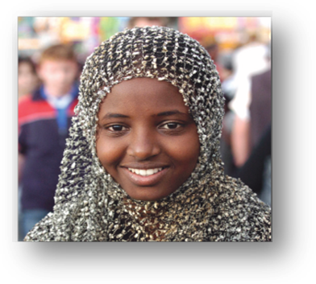
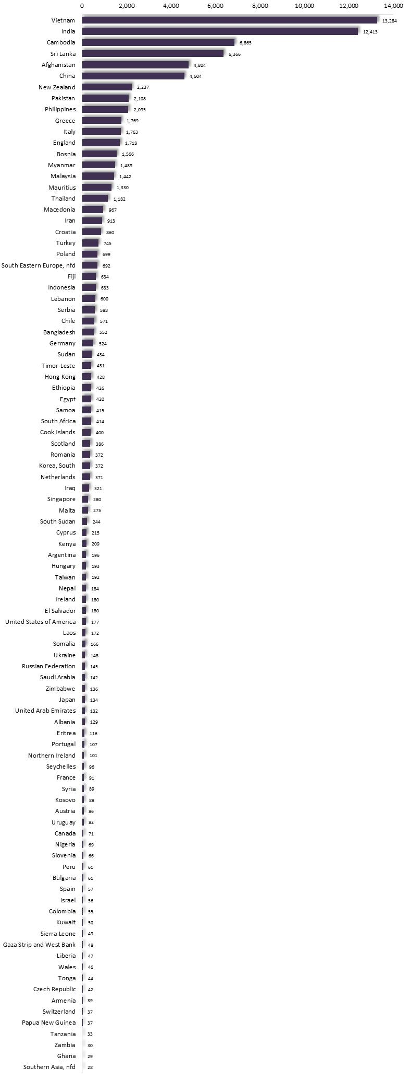
Geographic Distribution of Cultural Diversity
The map below depicts the distribution of overseas-born residents across Melbourne, featuring high proportions in Melbourne’s south-east, central Melbourne, and localities in the northern and western suburbs (Australian Bureau of Statistics, 2017d).

Per cent of Residents Born Overseas: Metropolitan Melbourne, 2016
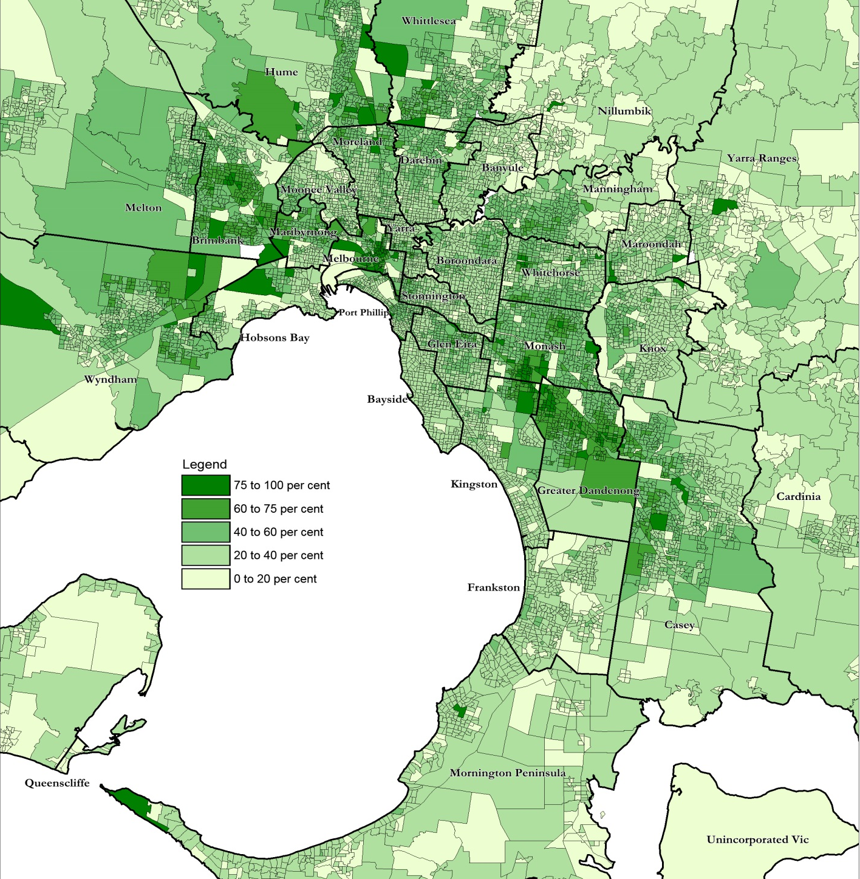

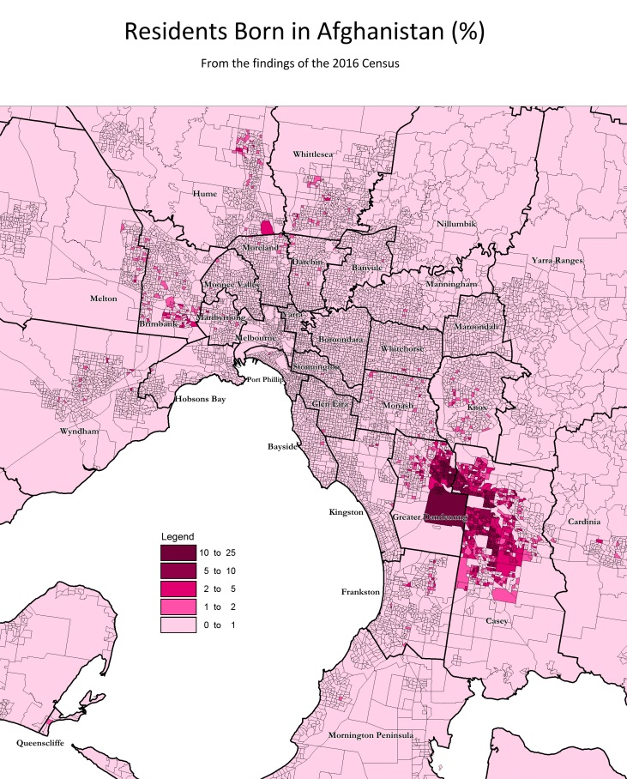
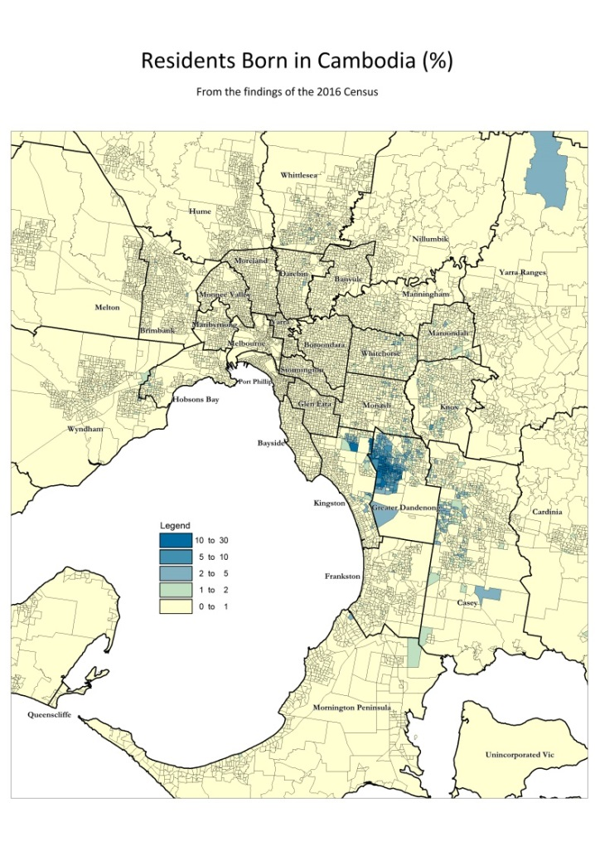
The maps below illustrate the extent to which the distribution of some birthplace groups is localized. Residents born in Cambodia or Afghanistan for instance, are largely concentrated in Greater Dandenong and neighbouring Casey. Residents from India are widely distributed across the south-east, northern and western suburbs, while substantial numbers of Sudanese-born residents live in the south-east and in Wyndham and Brimbank in Melbourne’s north-west.

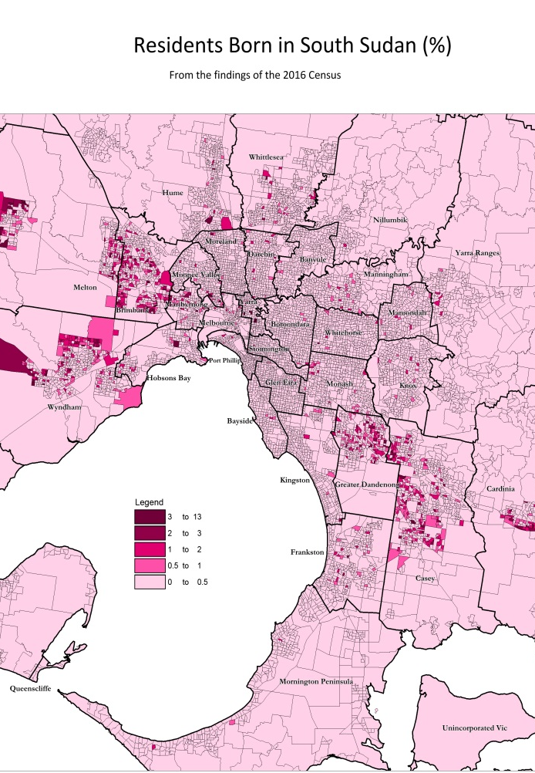
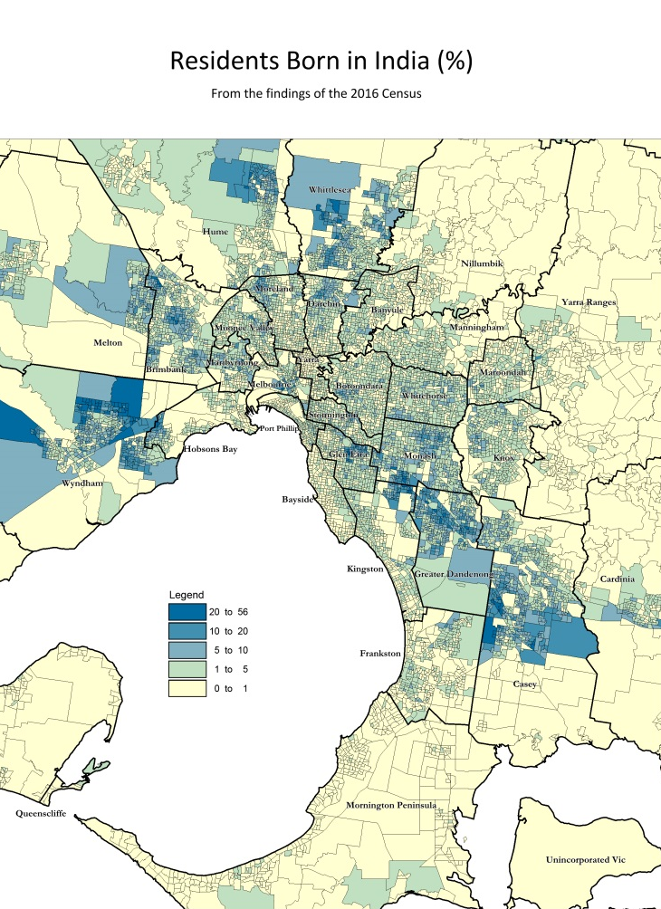

Recently-arrived Residents Residents who had arrived in Australia in the past 18 months, by birthplace
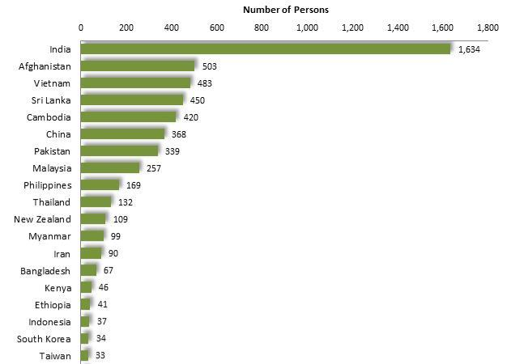
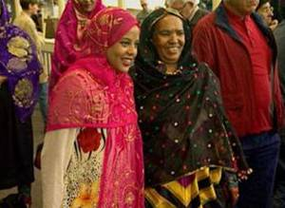
The 2016 Census recorded that approximately 9,740 residents of Greater Dandenong had arrived in Australia after 2014, representing 6.4% of the population – the third highest proportion in Victoria. Among these new arrivals, 28% were born in India, 7% to 8% were from each of Afghanistan, Cambodia, Sri Lanka and Vietnam, and others were from nations such as China, Malaysia, Pakistan, Philippines and Thailand. Together, these ten nations account for over four-fifths (81%) of residents who had arrived in Australia during the 18 months prior to the 2016 Census.

Settlement
In 2019/20, 4,092 people who had migrated from overseas settled in Greater Dandenong – the fourth highest level of settlement in Victoria (after Melbourne, Wyndham and Casey). Among them over half (57%) had arrived under immigration provisions, 37% under family reunion schemes, and 6% as humanitarian arrivals – a decline from 2011/12, when a third of settlers had arrived under humanitarian arrangements.
A notable feature of current, local settlement patterns is a rise in recent years. From 2011/12 to 2019/20, the annual rate of settlement into Greater Dandenong rose by 50%, from 2,737 to 4,092.
In 2019/20, over four-fifths (84%) of settlers across Victoria were aged less than 35 years, and just over half (54%) were females. Most were from countries such as India, accounting for 25%, as well as China, Vietnam, Philippines, Sri Lanka, Pakistan and Nepal – which together accounted for over half of all settlement during that year
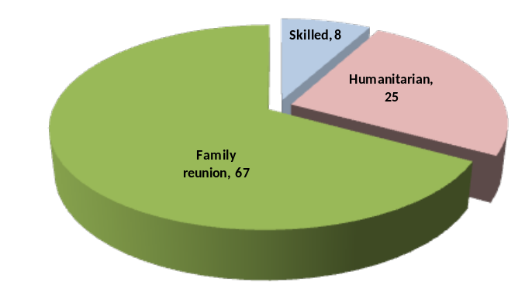
In the year 2016/17, the latest year for which more detailed, local information is available, A quarter of the settlers in Greater Dandenong were humanitarian migrants, numbering 388 – fewer than half the 750 who settled in Greater Dandenong in 2010/11 – though still the sixth highest number in Victoria.

Settlement by Migration Stream: Greater Dandenong, 2015/16
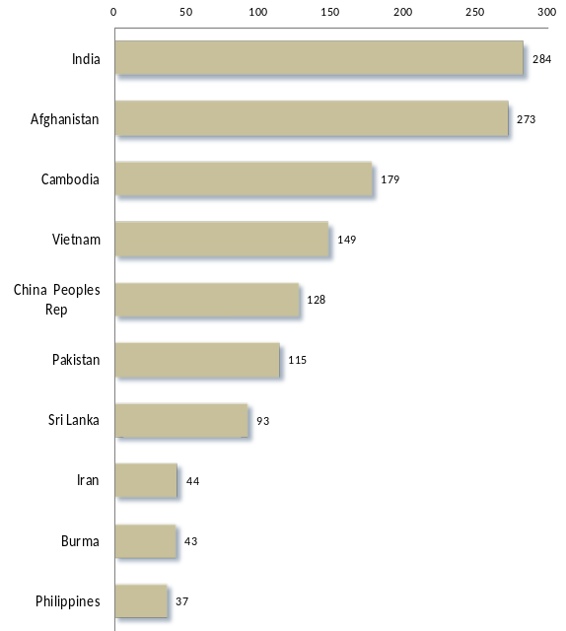

Settlement during that year was largely from countries such as India, Afghanistan, Cambodia, Vietnam and China, reflecting current humanitarian settlement trends, and family reunion with residents from these nations.

Settlement by Selected Birthplaces: Greater Dandenong, 2016/17
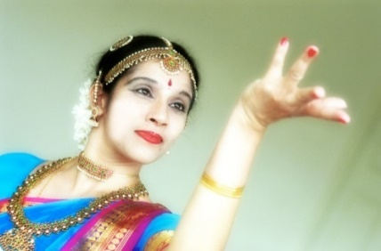

The geographic distribution of recent settlement in Melbourne shows high rates of settlement in central Melbourne as well as localities in the southeast, north and west of metropolitan Melbourne.
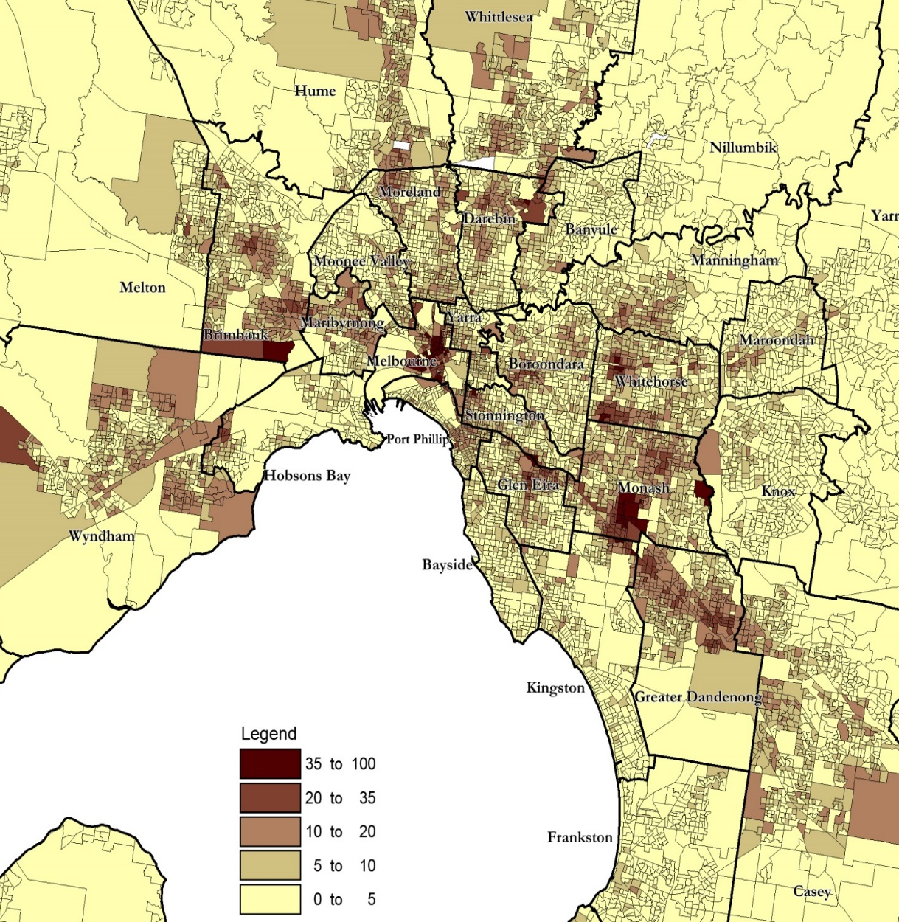

Percentage of Residents who had settled in Australia during the previous 4.5 years, Metro Melbourne, 2016

Attitudes to Settlement and Experience of Discrimination
The 2019 ‘Mapping Social Cohesion Survey’ 57% of respondents agreed that ‘Too many immigrants are not adopting Australian values’, while 41% stated that they considered Australia’s immigration intake ‘too high’. On the other hand, 68% of respondents agreed or strongly agreed that ‘accepting immigrants from many different countries makes Australia stronger’.
Reported experience of discrimination due to skin colour, ethnic origin or religion increased from 9% in 2007 to 19% in 2018 and 2019. The proportion of survey participants who had experienced such discrimination was highest among young people, averaging 28% among those aged 25-34 years during the past four surveys. The prevalence of the experience of discrimination was also high among people of non-Christian faiths, with 42% of Muslims reporting discrimination, compared with 38% among those of the Hindu faith, 24% of Buddhists, and 15% or less among those of major Christian faith groups.

The high number, and vulnerability, of settlers and asylum seekers
Many of the residents who have settled in Greater Dandenong from overseas are relatively vulnerable, having limited or no capital accumulation upon their arrival in Australia, limited exposure to either spoken or written English, little formal education, and lacking familiarity with Australian customs and institutions.
Social conditions among residents from Iran, Iraq, Afghanistan, Pakistan and Burma who had arrived in the 4.5 years prior to the 2016 Census, were examined as an illustration of the circumstances faced by people who have arrived in this community from nations disrupted by war, civil strife, famine and other difficulties. Most people from such circumstances arrive in Australia under humanitarian and family reunion provisions.
The findings of the 2016 Census show that 60% of those aged 15 years or more had left school before completing year 11 or its equivalent. Among young adults aged 20-24, 53% had left school early.
Forty-two percent of these recent settlers had limited fluency in the use of spoken English.
Median weekly income levels among these residents, reported in the 2016 Census, ranged from $459 among those from Afghanistan to $233 among those from Iran, averaging $283 - little more than two-fifths of the Victorian median of $651.
In addition to humanitarian and other settlers, 1,077 asylum seekers (bridging visa E holders) resided in Greater Dandenong in late 2020, the highest number in any Victorian municipality and representing 21% of asylum seekers in the state.
The substantial representation of recent settlers and asylum seekers in Greater Dandenong, coupled with the economic and social vulnerability of many, makes these communities a high priority for Council, and the challenge of addressing their needs, a task unsurpassed in the region.

Diversity of birthplaces among the residents of each municipality is measured as the probability that two people from a community, chosen at random, would come from different birthplaces. This measure provides an index of birthplace diversity which gives a balanced measure of the range of birthplaces and number of persons from each, and permits localities of widely varying population to be compared.
Markus, A. (2019). Mapping Social Cohesion Survey. Scanlon Foundation.
Markus, A. (2019). Mapping Social Cohesion Survey. Scanlon Foundation.

