Gambling
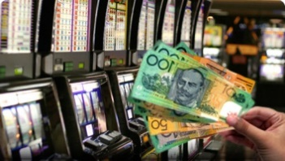
Gambling Losses
Legal gambling in Victoria includes sports betting, racing, lotteries, keno, lotto and the Casino. Electronic gambling machines. EGMs (or ‘pokies’) though, account for half of all gambling losses and most problems, as they are accessible and allow people to gamble continuously. Losses are highest among disadvantaged residents - those least able to afford them.
In 2018/19, $119 million was lost to electronic gambling machines (EGMs or ‘pokies’) in Greater Dandenong, an average of $326,882 each day, and equal to the cost of feeding nearly 49,000 children for one year. EGM gambling losses in that year were equivalent to $910 per adult - the highest rate of losses per adult in Victoria, nearly twice the metropolitan level of $531 per adult and over six times the rate of gaming losses in Boroondara ($143) - the most affluent municipality in the State. Since the introduction of EGMs in Victoria in 1992, over $3.4 billion had been lost to machines in Greater Dandenong alone. (in 2019 dollars)
In the year 2019/20, annual EGM losses in Greater Dandenong declined by 29% in real terms to $87 million, owing to the closure of gambling venues in late March, 2020. Information about the level and rate of EGM gambling loses, the number and density of EGMs, within Greater Dandenong and metropolitan Melbourne, in the year 2019/20, are set out below.

EGM Losses and Machines: Greater Dandenong and Metro. Melbourne, 2019/20
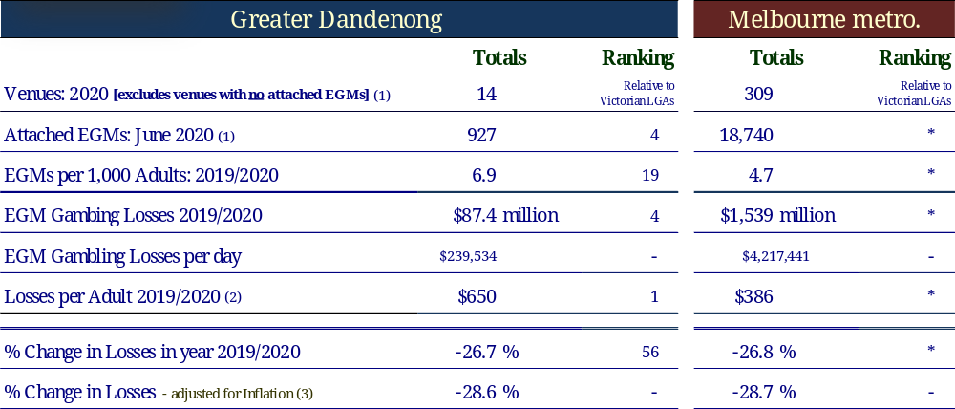

In addition to EGM losses, an estimated $130 million is lost each year by residents to other legal forms of gambling, bringing total annual gambling losses to nearly $250 million in this municipality – equivalent to $1,911 per adult. These gambling losses represent approximately 7% of total incomes in Greater Dandenong.
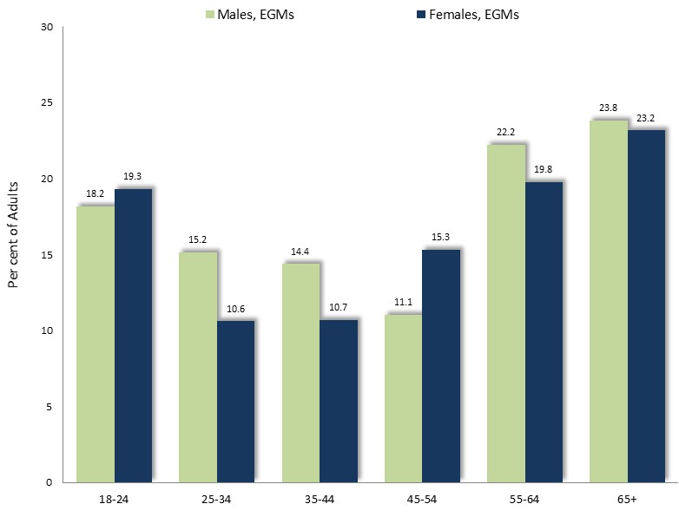
Prevalence of Gambling
Findings of a 2014 study of gambling patterns show that the prevalence of gambling varies widely with age, sex and type of gambling.
EGM gambling, for example, is slightly more popular among males, and is most widespread among younger adults and older people.

Proportion of Adults who Engaged in EGM Gambling at Least Once in the Previous Year, by Age and Sex: Victoria, 2014
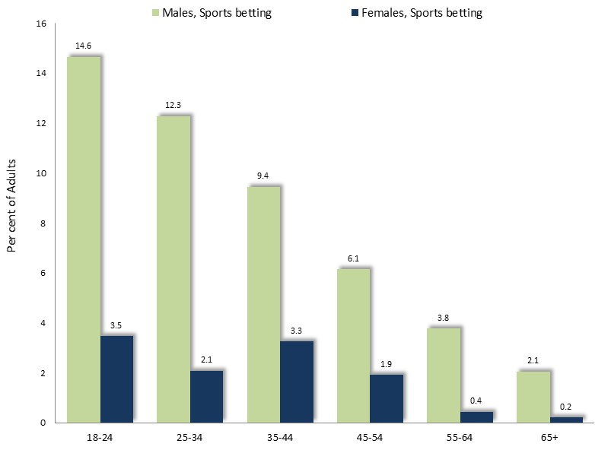
Sports betting follows a very different pattern, and is decisively most popular among males young people, with rates of participation declining steeply with age.

Proportion of Adults who Engaged in Sports Betting at Least Once in the Previous Year, by Age and Sex: Victoria, 2014
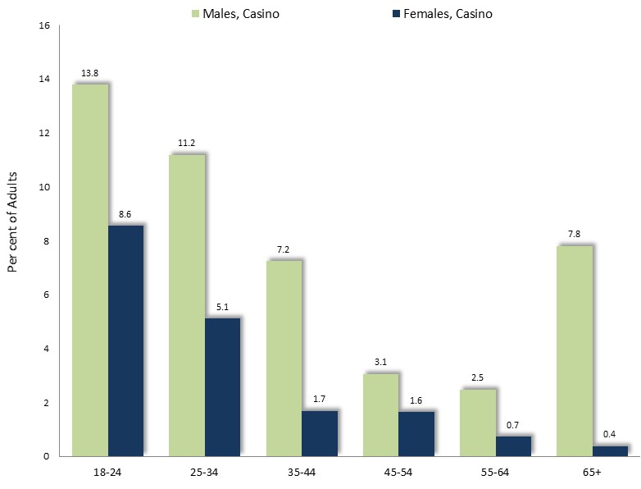

Participation in gambling at the Casino is most popular among males and young people, declining with age.

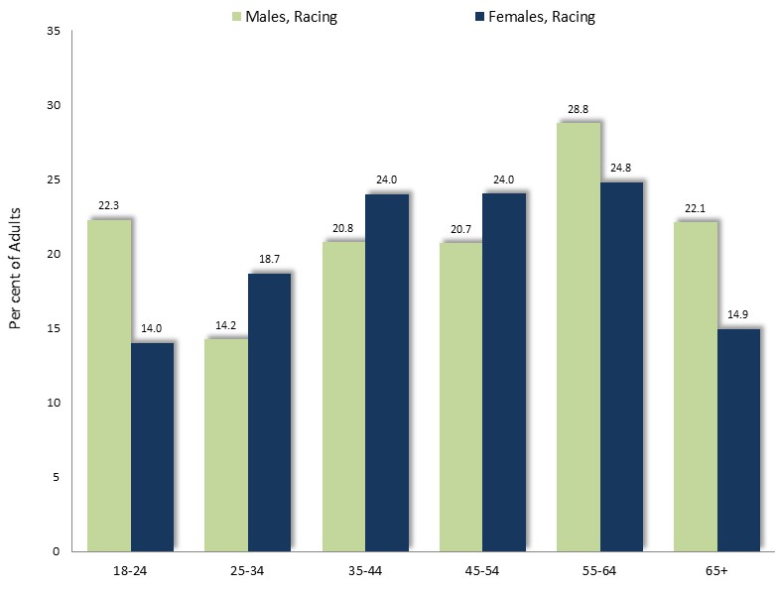
Proportion of Adults who Gambled at the Melbourne Casino in the Previous Year, by Age and Sex: Victoria, 2014

Levels of participation in gambling on horse and dog racing is more even, though most popular among middle-aged adults, and young men.

Proportion of Adults who Participated in Racing Gambling in the Previous Year, by Age and Sex: Victoria, 2014
Gambling Machines
957 EGMs operate at 15 clubs and hotels within Greater Dandenong – the second highest number of EGMs in any Melbourne municipality. Under State Government municipal gaming machine limits, 989 EGMs are permitted in Greater Dandenong. This means that 32 more EGMs may therefore be installed in venues in this city before the cap is reached. Clubs account for nine of the existing 15 venues and over half (59%) of the annual EGM gambling losses in Greater Dandenong ($70 million in 2018/19).

Impact of Gambling Losses
Many people gamble to ease boredom, social isolation or depression, while others are swayed by unrealistic expectations about the chances of winning, or lured by convenient access to venues. In addition though, gambling machines are designed to addict and deceive users, enticing them into losing more money than they otherwise might gamble.
Gambling-related problems generally arise when a person persistently loses more money than they, or their household, can comfortably afford. The resulting financial hardship often contributes to personal distress, family poverty, conflict, violence and breakup, decreased attendance and productivity at work, deceptive or criminal actions to obtain money, and homelessness.
At least 1 in 100 adults have severe gambling problems – a figure the Productivity Commission acknowledges may be three times higher; and about two-thirds of EGM gamblers experience gambling problems, ranging from mild to severe. Among the approximately 17% of adult residents of Greater Dandenong who use gaming machines, numbering approximately 21,000, annual gambling losses average approximately 19% of their gross income – the highest level of gaming losses relative to income levels in Victoria.
Gambling-related problems are most widespread among people with limited education, low incomes, manual occupations or without paid work – circumstances widespread in Greater Dandenong.
‘Benefits’ of Gambling
The gambling industry claims that it supports the community and creates jobs.
However, in 2018/19, the clubs in Greater Dandenong returned just 1.6% of their gambling revenue to the community as gifts, donations, sponsorships and support for veterans.
Moreover, investigations of the spending patterns of gambling show that funds lost to gambling machines are largely diverted from expenditure on goods and services, such as household items, with the consequence that growth in the retail sector is lower than it would have been if EGMS had not been introduced. For example, gaming venues often detect from expenditure at local businesses as they divert expenditure from other goods and services.
Accordingly, evidence indicates that expenditure on EGM gambling creates fewer jobs in gambling venues than those lost from other sectors of the economy. A 2006 study of Victorian and Western Australian gambling concluded that 3.2 jobs were created for every million of EGM gambling expenditure, compared with 8.3 jobs per million services from sales of beverage and 20.3 jobs for every million spent on meals and food (South Australian Centre for Economic Studies, 2005).
Weighing the evidence concerning the economic effects of gambling, the Victorian Competition and Efficiency Commission cited with endorsement the conclusions of the Productivity Commission in its 2010 review of the gambling industry, that “… the long-run economy-wide impact of an expansion in gambling activity is likely to be neutral.” (2012: 77).
How Council may Address Gambling Problems
- Advocacy for gambling reforms such as lower bet and cash withdrawal limits, shorter venue opening hours, fewer EGMs, less gambling advertising and no political donations by the gambling industry.
- Informing residents about the nature and effects of gambling problems and sources of support, through websites, newspapers, social media and public forums.
- Support for community initiatives such as the promotion of alternative recreational pursuits and assisting local Gambler’s Help with public awareness activities.
- Opposing applications for EGMs or new venues in vulnerable localities.
How Council Collaborates to Strengthen its Impact
- The Alliance for Gambling Reform: A partnership of councils, community groups, academics and residents, the Alliance advocates for gambling reform and assists councils with local events and publicity. With its professional staff, the Alliance responds swiftly to industry developments and media opportunities, lifting the voice of local government and carrying its concerns to State and Federal Governments.
Membership is free, though many councils provide financial support.
- Local Government Working Group on Gambling: Convenes regular meetings where councils learn about current developments, share information and collaborate.

45% of all legal gambling losses in 2015/16
Calculated on the basis of the cost of the Healthy food basket of 2014, of $126 per fortnight, adjusted for inflation to $137 in 2019, representing $68 per week, multiplied by 0.7 – the cost of living for one child, relative to that of an adult, according to the OECD poverty scales - to give an approximation of the cost of feeding a child for a week. The resulting figure, of $47, is multiplied by 52 to give $2,444 – the estimated cost of feeding a nutritious diet to a child for one year. Finally, the EGM gambling losses of $119 million for 2018/19 are divided by this figure to give 48,700: the number of children which these losses could feed in one year.
Hare, S. (2015). Study of Gambling and Health in Victoria, Australia. Victorian Responsible Gambling Foundation and Victorian Department of Justice and Regulation.
Australian Gambling Research Centre (2014). The impact of gambling problems on families - AGRC Discussion Paper No. 1 – November 2014 Costello, T. (2008). Rudd’s Crack at State Pokie Habit. Herald Sun, 1 April 1998. Commonwealth of Australia (2008). Submissions to the Senate Standing Committee on Community Affairs Inquiry into the Poker Machine Harm Reduction Tax (Administration) Bill 2008, the Poker Machine Harm Minimization Bill 2008 and the ATMS and Cash Facilities in Licensed Venues Bill November 2008. Commonwealth Government, Canberra. Ferland, F., Fournier, P., Laouceur, R., Brochu, P., Bouchard, M. and Paquet, L. (2008). Consequences of Pathological Gambling on the Gambler and His Spouse. Journal of Gambling Issues, Vol. 22, Dec. 2008 Healthy Wealthy and Wise Women (Undated). Who Picks up the Tab? Issues and Dilemmas for services providing mainstream support to women affected by gambling in Melbourne: Western Metropolitan Region. Women’s Health in the South-east, Melbourne. Lin, E., Casswell, S. and You, R.Q. (2008). Assessment of the Social Impacts of Gambling in New Zealand. Centre for Social and Health Outcomes Research and Evaluation, Auckland. Livingston, C. (2008). Testimony before the Senate Standing Committee on Community Affairs. Reference: Poker Machine Harm Reduction Tax [Administration] Bill, Poker Machine Harm Minimization Bill and ATMs and Cash Facilities in Licensed Venues Bill. Hansard. 11 September 2008: Commonwealth Government, Canberra. Markham, F. Doran, B. and Young, M. (2016). The Relationship between electronic gaming machine accessibility and police-recorded domestic violence: a spatio-temporal analysis of 654 postcodes in Victoria. Australia, 2005-2014. Soc Sci Med. Aug 162:106-14. Markham, F., Young,. And Doran, B. (2014). Gambling Expenditure Predicts Harm: evidence from a venue-level study. Addiction, Vol. 199, pp. 1509-1516 McCready, J., Mann, R., Zhao, J. and Eves, R. (2008). Correlates of Gambling-related problems among older adults in Ontario. Journal of Gambling Issues, Vol. 22, Dec. 2008 Moody, G. (1995). The Roots, Significance, Value and Legislation of Gambling. Journal of Gambling Studies, Vol. 11 (1), Spring, pp. 35-59, 1995. Science Alert (2008). Depressed gamblers Risk Addictions. Science Alert. Published June 2, 2008. Featured in Canadian Responsible Gambling. South Australian Centre for Economic Studies. (2005). Community Impacts of Electronic Gaming Machine Gambling. Adelaide. Suomi, A., Jackson, A. Dowling, N.A., Patford, J., Thomas, S.A., Harvey, P., Abbott, M., Bellringer, M.E., Kozoil-McLain, J. and Cockman, S. (2013). Problem Gambling and Family Violence: family member reports of prevalence, family impact and family coping. Asian Journal of Gambling Issues and Public Health. Vol. 3, No. 13, pp. 1-15. Suomi, A., Jackson, A., Dowling, N.A., Lavis, T., Patford, J., Thomas, S.A., Harvey, P., Abbott, M., Bellringer, M.E., Koziol-McLain, J., Battersby, J. and Harvey, M. (2014a). Problem gambling and family violence: Prevalence and patterns in treatment-seekers. Addictive Behaviors, Volume 39, Issue 12, December 2014, pp. 1713-1717 Suomi, A., Jackson, A., Dowling, N.A., Lavis, T., Patford, J., Cockman, S., Thomas, S.A., Harvey, P., Abbott, M., Bellringer, M.E., Koziol-McLain, J., and Battersby, J. (2014b). Problem Gambling and Intimate Partner Violence: a systematic review and meta-analysis. Trauma, Violence and Abuse. Vol. 17, No. 1 pp. 1-19 Walker, D. (2008). Challenges that Confront Researchers on Estimating the Social Costs of Gambling. American Gaming Association 10th Anniversary Research Series.
South Australian Centre for Economic Studies (2005B). Problem Gambling and Harm: towards a national definition. South Australian Centre for Economic Studies. Adelaide.
Rintoul, A. and Deblaquiere, J. (2019). Gambling in Suburban Australia. Institute of Family Studies, Melbourne.
South Australian Centre for Economic Studies (2005B). Problem Gambling and Harm: towards a national definition. South Australian Centre for Economic Studies. Adelaide.

