Disability

The 2016 Census inquired as to whether respondents had a severe or profound disability requiring them to obtain daily assistance with mobility, communication or personal care. Such individuals were considered to have severe or profound disabilities. Within Greater Dandenong, 9,645 residents, or 6.8% of the population, recorded that they had a severe or profound disability. This percentage is slightly higher than the level of 6.0%, recorded ten years earlier in the 2006 Census.
Notably, the 5.5% of Australians recorded by the 2016 Census as having a disability that required them to obtain daily assistance, represented approximately a third of the 18% of Australians found to have a mild, moderate, severe or profound disability, in the 2015 National Survey of Ageing and Disability (ABS, 2017).
Overview
The table below presents an overview of the number and proportion of severely or profoundly disabled residents in Greater Dandenong, by gender, age, birthplace and type of accommodation.
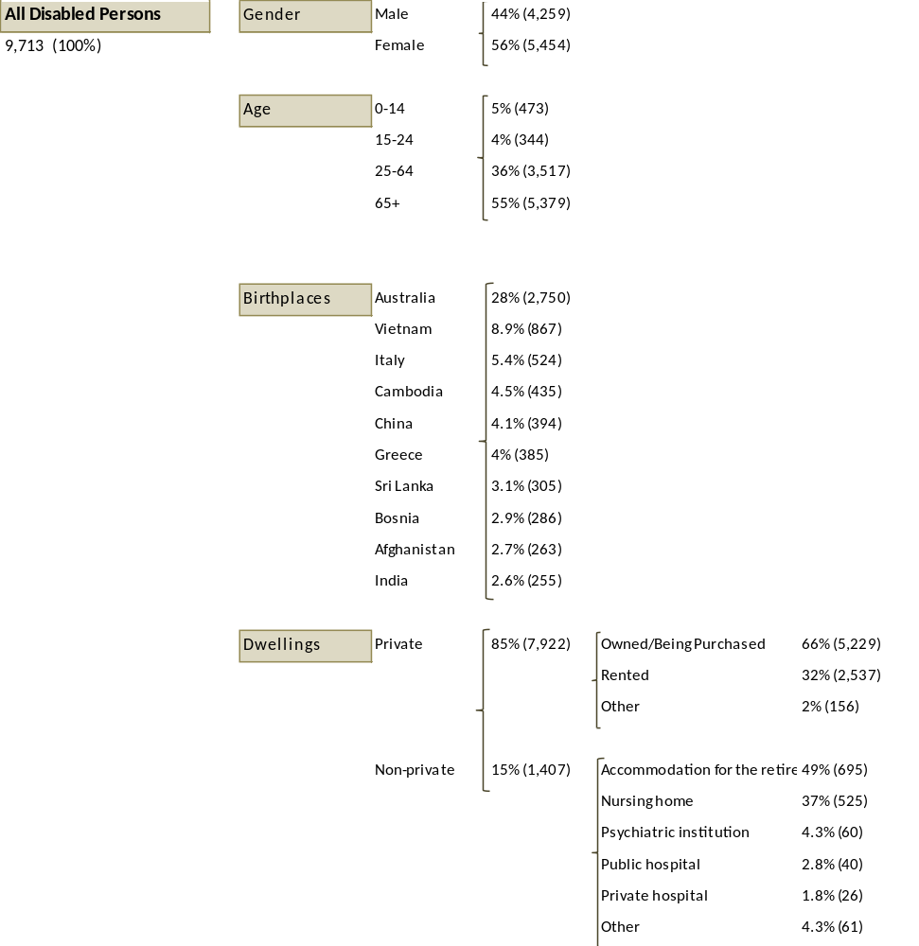
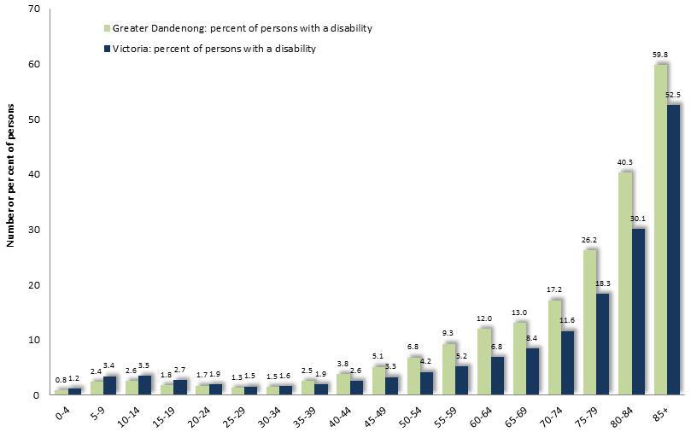
Age Prevalence of Disability by Age: Greater Dandenong and metropolitan Melbourne, 2016
The prevalence of severe or profound disability rises markedly with age, from less than 2% among residents aged up to 24 years, to 4.6% among those aged 25-64, then 13% of those aged 65-69, and 71% of those over 90.

Number of Persons with a Disability, by Gender:
Gender Greater Dandenong, 2016
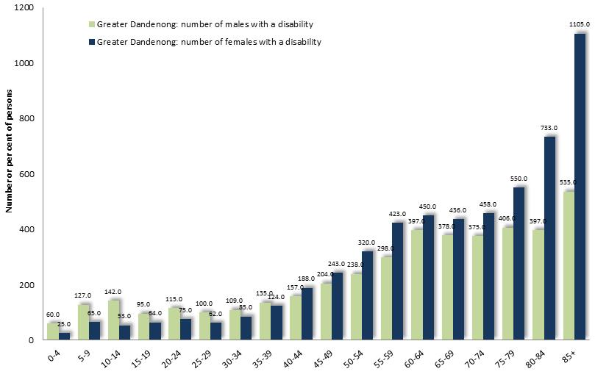
Females account for 56% of Greater Dandenong residents with a severe or profound disability and males for the balance, of 44%. For younger residents, males predominate among those with a disability, while among people aged over 75 years, women form a majority, due to their greater longevity.

Number of Persons with a Disability,
by Birthplace: Greater Dandenong, 2016
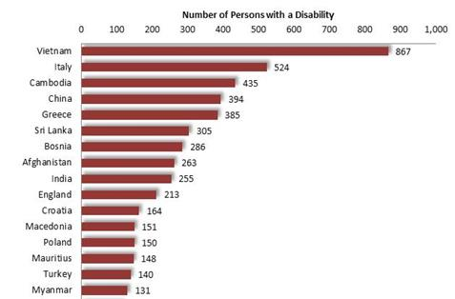
Birthplaces
The number of people of each birthplace who have a severe or profound disability largely reflects the overall mix of birthplaces in Greater Dandenong and the age profile of residents of each birthplace.
Among severely or profoundly disabled residents in Greater Dandenong, 28% were born in Australia, 9% in Vietnam, 5% in Italy, 4.5% in Cambodia and 4% in China.

Disabled Persons in non- Private Accommodation, by Type of Dwelling:
Greater Dandenong, 2016
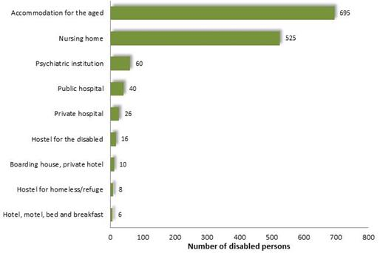
Living at Home
Of all persons with a severe or profound disability in Greater Dandenong, 85% reside in private dwellings and 15% in non-private settings such as a nursing home or other age accommodation.
Of those living at home, 14% or 1,165, live alone.

Education
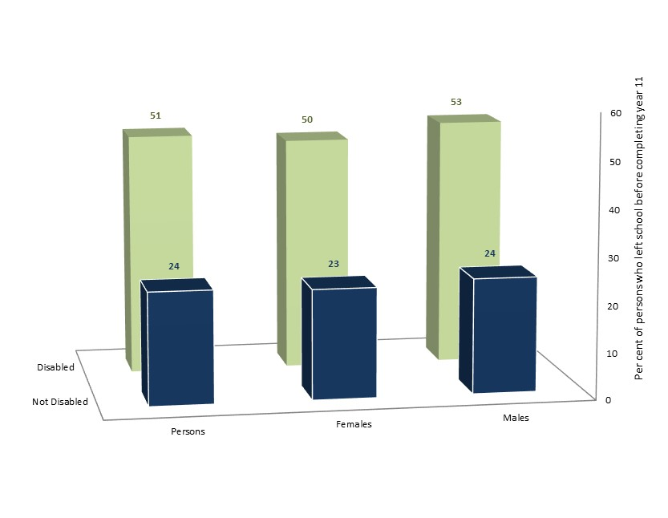
Year of School Leaving by Disability Status: Metro Melbourne, 2016

About half (51%) of Greater Dandenong residents aged 25-54 years, with severe or profound disabilities, had left school before completing year 11, compared with approximately a quarter (24%) of others the same age (diagram left).

Employment by Disability Status: persons 20-445, Greater Dandenong, 2016
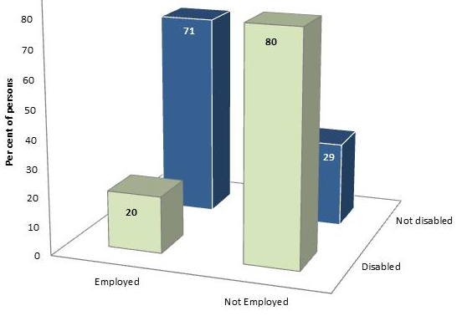
Employment
The findings of the 2016 Census reveal that 20% of disabled people in Greater Dandenong, aged 20-44 were in paid employment, compared with 71% of residents of the same age, without a disability.

Disability and Cultural Diversity
Aboriginal and Torres Strait Islanders
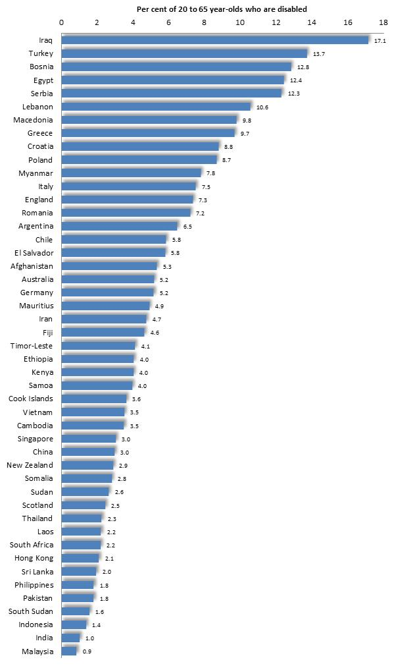
Among Aboriginal and Torres Strait Islanders aged 20 to 65 years in Victoria in 2016, 9.7% had a severe or profound disability, compared with 3.1% of non-indigenous residents. This is a pattern repeated in most municipalities.
Cultural Diversity
The prevalence of disability also varies among people of different birthplaces. In Greater Dandenong, the proportion of those aged 20 to 65 years who had a severe or profound disability ranged from over 10 per cent among those from Iraq, Turkey, Egypt, Bosnia, Serbia and Lebanon, to about 1% of residents from India and Malaysia.
Prevalence of Disability by among persons aged 20 to 65 years, and from selected birthplaces: Greater Dandenong 2016

An examination of the findings of the 2016 Census, show that the prevalence of disability tends to be higher in parts of the middle and outer metropolitan area, including Greater Dandenong – with the exception of south Keysborough, and parts of Moreland, Brimbank, Whittlesea and portions of Wyndham.

Per cent of Persons with a Severe or Profound Disability: inner and middle-metropolitan Melbourne, 2016
