Estimates of LGBTI+ populations in Australia

This note presents estimates of the proportion of Australians, aged over 16, who are lesbian, gay, bisexual, trans or gender diverse.
This information is derived from several national surveys, representing a combined sample of 45,000 people across Australia, and published by the Australian Bureau of Statistics (ABS) in the report ‘Estimates and characteristics of LGBTI+ populations in Australia’, accessible here.

Gender Experience
Among Australians aged 16 years or more, 0.6% are trans men or women, and 0.3% identify as non-binary.

Gender Experience by age

Persons | Trans men and trans women | Non-binary *
16–24 | 1.0 | 1.0
25–34 | 0.6 | 0.5
35–44 | 0.6 | 0.1
45+ | 0.5 | 0.1
16+ | 0.6 | 0.3

These proportions decline with age, with the percentage of people who are trans women or men halving from 1% among 16-24-year-olds, to about 0.5% among other age groups.
The proportion of Australians aged 16 or more who identify as non-binary declines more steeply still, from 1% among Australians aged 16-24, to 0.1% among those aged 35 or more.

Gender Experience by age
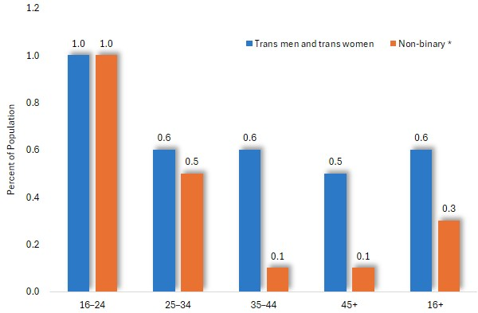

Sexual Orientation by age
1.5% of Australians aged 16 or more are gay or lesbian, 1.7% bisexual and 0.4% choose alternative terms to describe their sexual orientation.
The highest prevalence is among 20-24-year-olds, of whom 2.2% of identify as gay or lesbian and 6.4% as bisexual.
These percentages decline with age, so that among people aged 65 years or more, 0.6% identify themselves as gay or lesbian, and 0.2% as bisexual.

Sexual Orientation by age

Persons | Gay or lesbian | Bisexual | Different term | Total LGB+
16–19 | 1.2 | 4.8 | 1.1 | 6.9*
20–24 | 2.2 | 6.4 | 1.2 | 10
25–29 | 2.7 | 4.1 | 1.1 | 7.9
30–34 | 2.7 | 1.8 | 0.5 | 4.8
35–39 | 1.8 | 1.1 | 0.4 | 3.4
40–44 | 1.7 | 0.9 | 0.3 | 2.8
45–54 | 1.3 | 0.5 | 0.2 | 2.1
55–64 | 1.3 | 0.3 | 0.1 | 1.6
65+ | 0.6 | 0.2 | 0.1 | 0.9
16+ | 1.5 | 1.7 | 0.4 | 3.6
* The ABS advises that in some instances, the sum of the percentages in each category differs from the total, due to procedures designed to randomize the data to preserve confidentiality.

Sexual Orientation by age

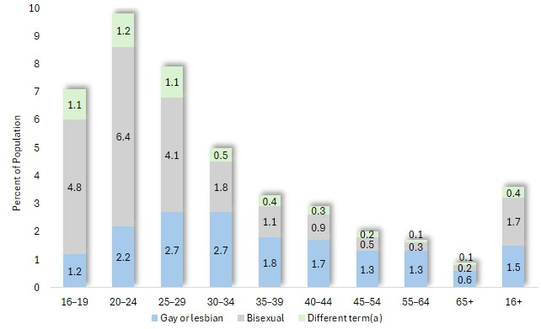

Sexual Orientation by Age and Gender
The charts below, illustrate the proportion of Australians aged 16 or more who are LGB+, by age and sex.
Sexual Orientation by Age and Gender: Gay or Lesbian
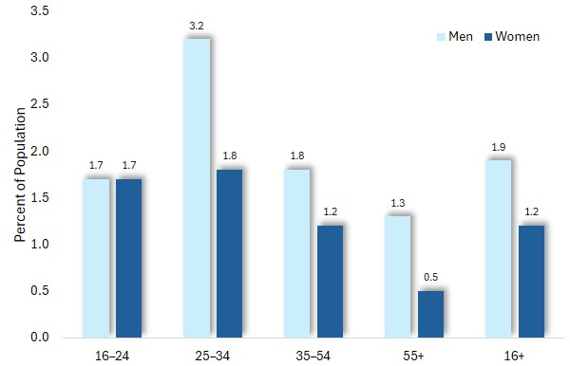
The proportion of men who are gay generally exceeds the proportion of women who are lesbians.
Among 25-34-year-olds for example, 3.2% of males are gay and 1.8% of females identify themselves as lesbians.

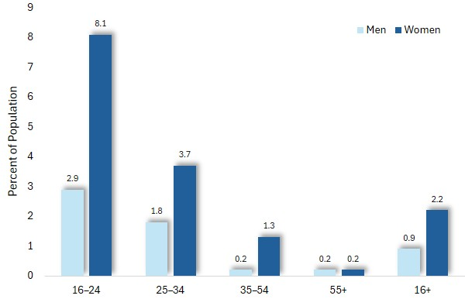
Sexual Orientation: Bisexual
Bisexuality is most common among women, reaching its highest prevalence, of 8.1%, among 16-24-year-old women - nearly three times the corresponding proportion of males (at 2.9%).
Bisexuality declines markedly with age, falling among women, from its peak of 8.1% among 20-24-year-olds to 0.2% among those aged 55 or more.

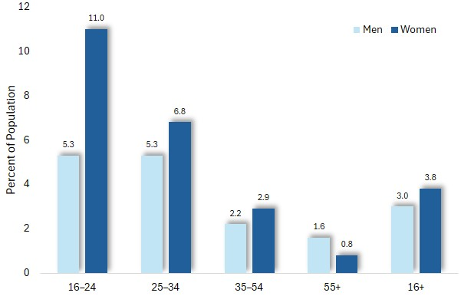

Sexual Orientation: LGB+
The chart on the left shows the proportion of people who are LGB+, a measure which includes other terms used to describe sexual orientation.
Reflecting the trends shown above, it depicts a decline in prevalence with age and the higher proportion of women who identify as LGB+.

Sexual Orientation: differences in prevalence by state and territory
The proportion of Australians aged 16 or more who identify themselves as LGB+ differs slightly among the states and territories of Australia, reaching its highest prevalence, at 5.9%, in the Australian Capital Territory and falling to its lowest, at 2.9%, in Western Australia.

Proportion of people aged 16+ who are LGB+, by state and territory
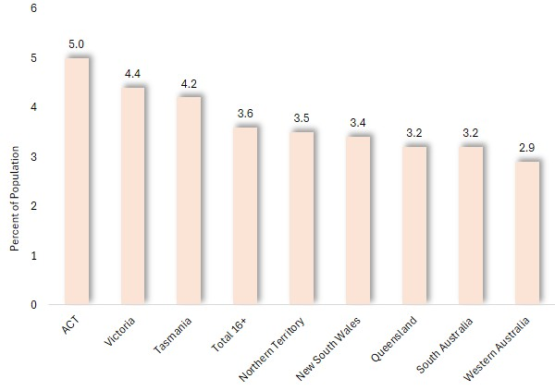

Sexual Orientation among Trans and non-Binary People
Three-quarters of non-binary people and 16% of trans men and women, identify as LGB+, compared with 3.3% of CIS women and men.

Per cent of people aged 16+, who are LGB+
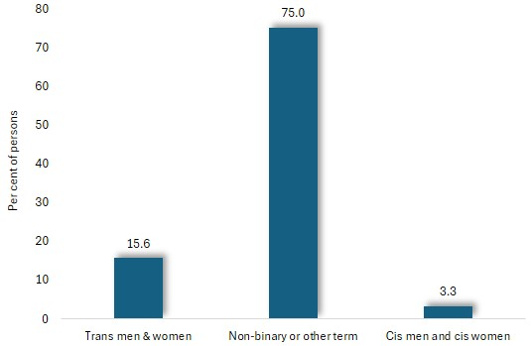

Estimated Number of LGB+ Residents, by Municipality
The tables below present estimates of the number of LGB+ residents, based on the age-specific prevalences shown earlier, and the 2026 population of corresponding ages in each municipality, drawn from estimates featured in the State Government publication ‘Victoria in Future’.
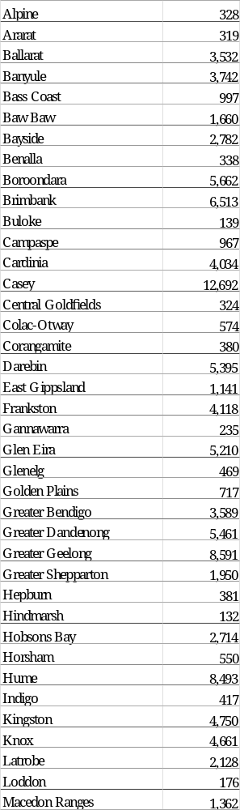
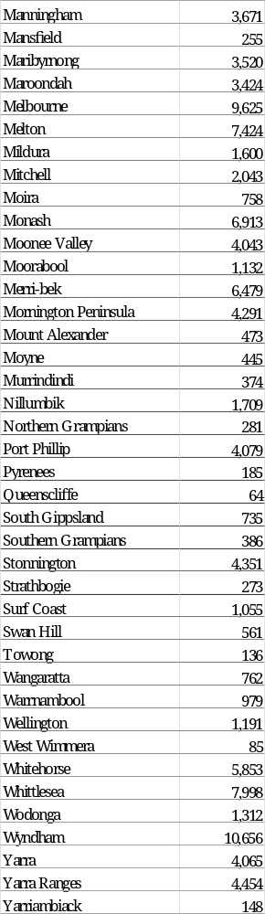

For this reason, the figures shown in this chart exceed the sum of the percentages of people of each age group, who identify as gay/lesbian or as bisexual.

