Disability, Ageing and Carers Survey: 2022

A Summary of Findings

The Disability, Ageing and Carers Survey was conducted among 13,700 households and 1,100 care facilities throughout Australia, between June 2022 to February 2023.

These notes present brief summary of its principal findings.

**Disability by Age**

Approximately one-fifth (19.2%) of Australians, including similar proportions of women and men, live with disability. Its prevalence rises steadily with age, from about 6% among 0-4 year olds, to a third of people approaching their older age, and over four-fifths of those aide 90 years or more.

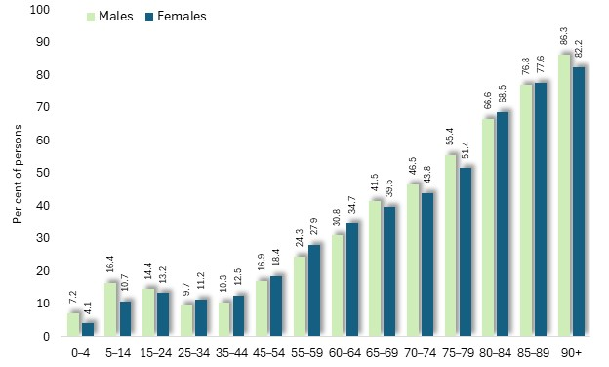

Prevalence of disability by age and sex: Australia, 2022

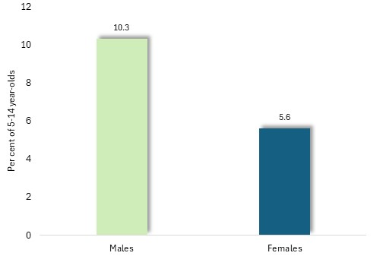

Among people aged 5-14 years, over 16% of males and 11% of females have a disability (diagram above). This disparity is also reflected in the proportion of 5-14 year-olds with severe or profound disability, which includes 10.3% of males and 5.6% of females (diagram, left).

Prevalence of severe or profound disability by sex among persons aged 5-14 years: Australia, 2022

**Level of Disability**

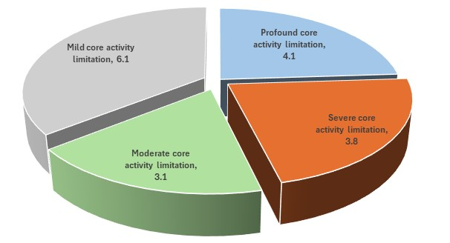The proportion of disabled Australians with each of four levels of limitation, from mild to profound, is illustrated in the accompanying chart. Profound disability is experienced by 4.1%, accounting for nearly a quarter of people living with disability.

Percentage of disabled persons with core activity limitations, by level of limitation: Australia, 2022

**Schooling and Employment Restrictions**

Approximately one in ten Australians experience a restrictions upon their employment or participation in education, as a consequence of disability. The proportion of people who experience such constraints declines in early adulthood, before rising in older age.

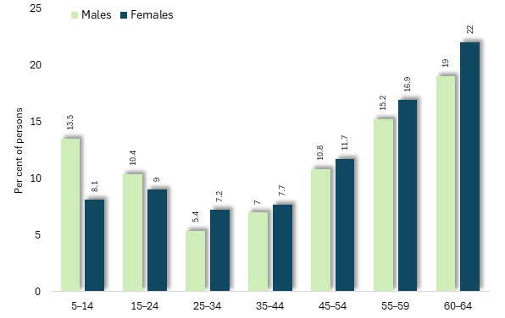

Schooling and employment restriction among persons with disability, by age: Australia, 2022

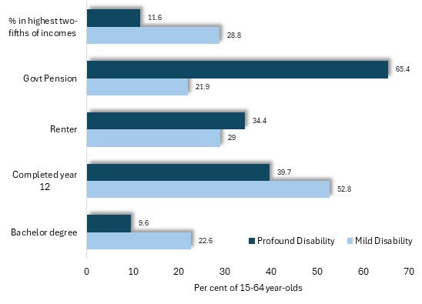**Disability Level and Life Circumstances**

People with a profound disability are less likely than those with a mild disability, to have completed secondary school or to hold a university degree, more often rent their accommodation, three times more likely to be dependent upon government pensions or benefits, and are less often among the highest two-fifths of income earners.

Selected outcomes by level of disability among persons aged 15-64 years: Australia, 2022

**Employment**

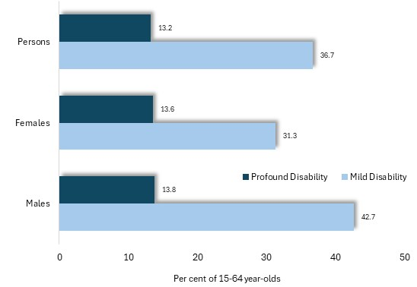Among people aged 15 to 64 years, those with a mild disability are approximately three times more likely to hold full-time employment as those living with profound disability. This disparity is most pronounced among males, among whom 43% with mild disability hold full-time jobs, compared with 14% of those with profound disability.

Proportion of 15-64 year-old persons in paid full-time employment, by level of disability and sex: Australia, 2022

**Employment Restrictions and Assistance**

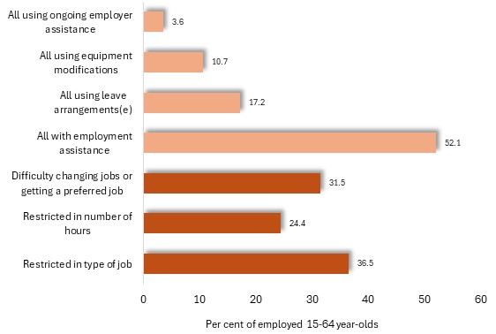Between a quarter and a third of employed, disabled people aged 15-64 years, experience restrictions upon the type of job which they may hold, their job mobility or their hours of work (darker orange in the chart).

Just over a half receive some kind of employment assistance, such as leave arrangements, equipment or ongoing assistance from their employer (lighter orange).

Employment restrictions and assistance, among persons with a disability, aged 15-64 and living in private dwellings: Australia, 2022

**Use of Mobility Aids**

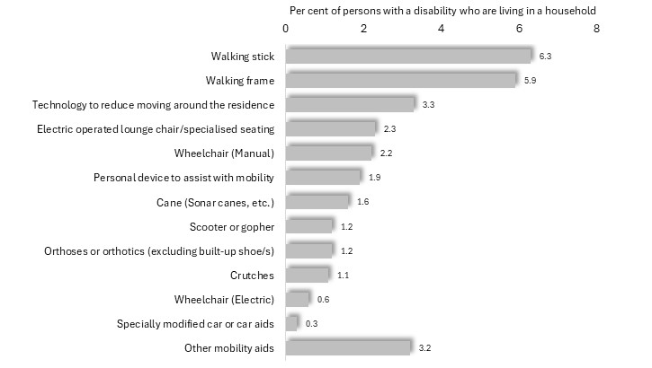A variety of mobility aids are used by people with a disability who are living within private households; among them: walking sticks and frames, specialised seating, wheel-chairs scooters and others.

In total, 17% use mobility aids.

Proportion of disabled persons who are living in private dwellings, who use mobility aids, by type of aid: Australia, 2022

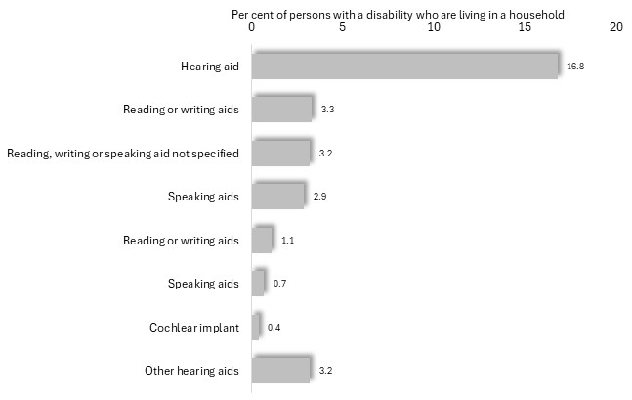**Use of Communication Aids**

Of communication aids used by disabled people living in private households, the most prevalent are hearing aids, used by approximately 17%, or one in six of them. Overall, 24% of disabled people use communication aids of some kind.

Proportion of disabled persons in private dwellings, who use communication aids, by type of aid: Australia, 2022

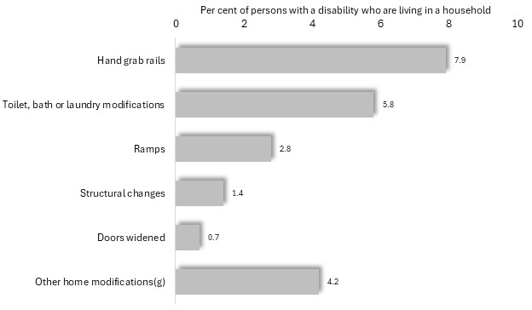

**Home Modifications**

A variety of home modifications are incorporated into the homes of people with disabilities, including hand grab rails, modifications to the toilet or bathroom, and ramps.

Proportion of disabled persons in private dwellings, who have home modifications, by type of modification: Australia, 2022

**Unmet Needs**

A sequence of questions inquired about the needs of people who are living with disabilities at home, that are not currently met. Among those with profound disabilities *aged up to 64 years*, approximately one-third experience unmet needs for assistance with cognitive tasks or mobility, while an appreciable proportion have unmet needs for assistance with mobility, communication, household chores and other activities.

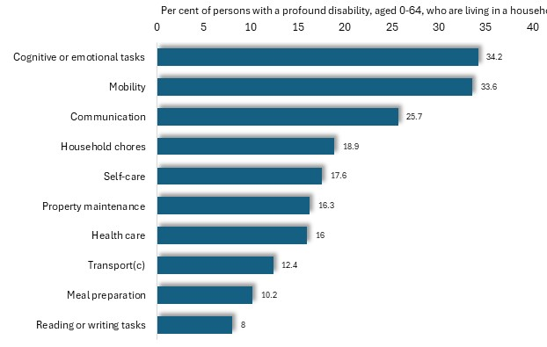Per cent of persons with a profound disability, aged 0-64 years, and living in a private household, who have unmet needs, by type of need: Australia, 2022

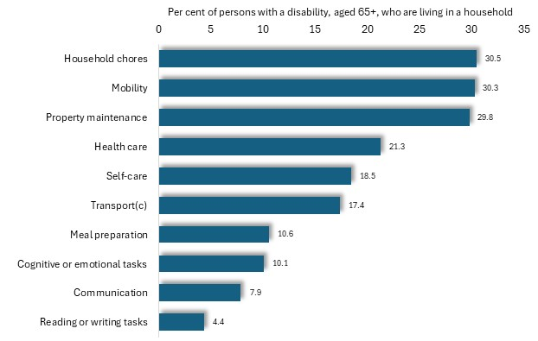Of people with profound disabilities and *aged 65 years or more*, nearly a third identify assistance with tasks such as household chores, property maintenance and mobility among their unmet needs. Notably, among this group, only one in ten perceived an unmet need for assistance with cognitive tasks – the primary unmet need among younger, disabled people.

Per cent of persons with a disability, aged 65 years or more, and in private households, who have unmet needs, by type of need: Australia, 2022

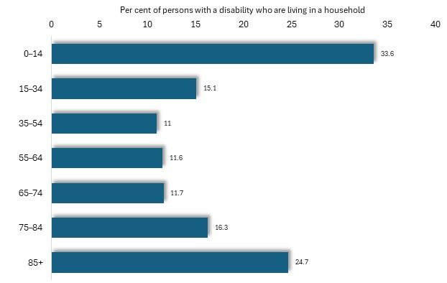The proportion of disabled people who feel that they need more assistance with core activities than that currently available to them varies with age, declining from approximately a third of those aged 0-14 years, to little more than one in ten of people in their middle age, before rising to about a quarter of those aged 85 years or more.

Per cent of persons with a disability and in private households, who need more assistance with core activities than currently provided, by age: Australia, 2022

**Sexual Orientation**

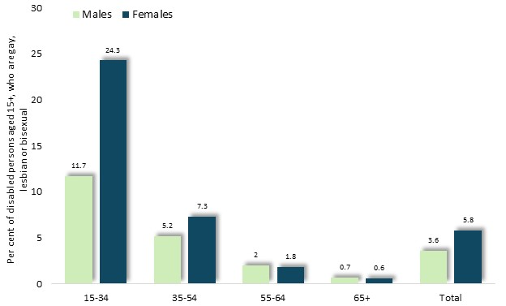Approximately one in twenty people aged 15 or more and living with disability, identify themselves as gay, lesbian or bisexual, including 2.6% of males and 5.8% of females.

Notably this proportion declines with age, from nearly one fifth (18.5%) of those aged 15 to 34, to less than 1% among people over 64.

Per cent of disabled persons aged 15 years or more, who are gay, lesbian or bisexual, by age: Australia, 2022

**Public Transport Access**

Alighting from vehicles or carriages, difficulty standing, pain relating to seating, and anxiety about the use of public transport, are among the circumstances which set constraints upon the use of such facilities by disabled people.

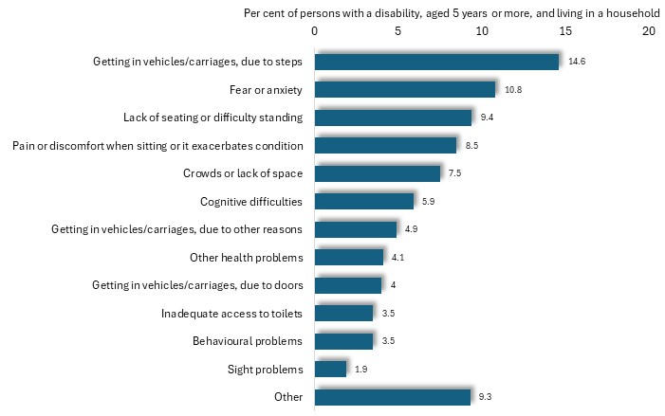

Per cent of persons with a disability and aged 5 years or more, who experience difficulty using public transport, by type of difficulty: Australia, 2022

Among disabled persons living in private households and aged 5 or more, 37% experience one or more of these difficulties. A further 6% declared that they do not have access to public transport, in any case.

**Situations which are Avoided**

Many survey respondents with a disability, and aged 15 years or more, stated that they sometimes avoid situations due to their disability, including visiting family or friends, attending other social settings, and public places such as shops, restaurants, cafes and bars.

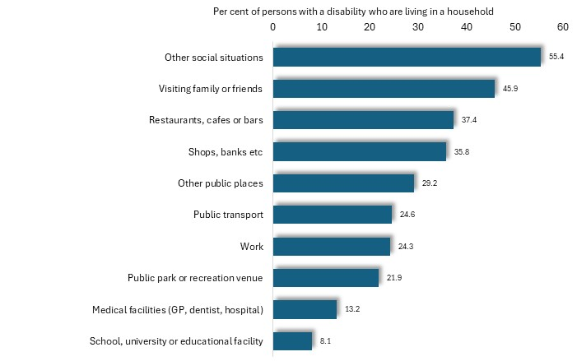Percent of disabled persons aged 15 years or more, living in private households, who avoid situations, by type of situation: Australia, 2022

**Physical and Emotional Abuse**

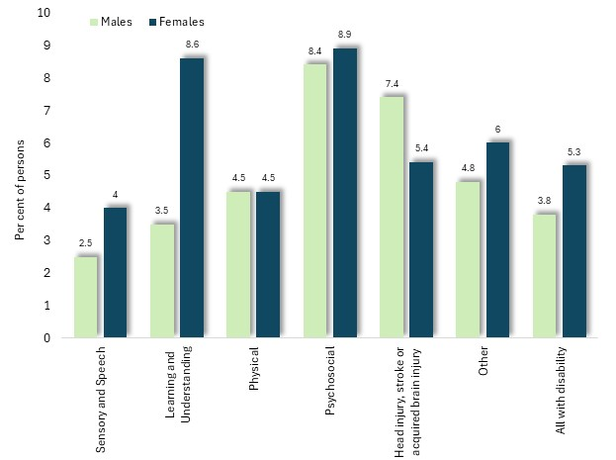Further questions inquired about the experience of abuse during the previous 12 months, by people with a disability. Physical abuse had been experienced by 4.5% of those aged 18 years or more, including 5.3% of women and 3.8% of men. The highest prevalence of abuse was recorded among people with psychosocial or cognitive disabilities, and those with head injuries.

Notably, among people with learning or understanding disabilities, 8.6% of women and 3.5% of men had experienced physical abuse.

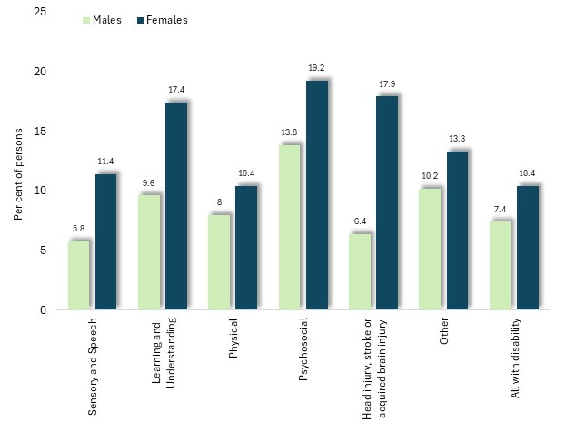Per cent of disabled persons who had experienced physical abuse during the previous 12 months, by type of disability and age: Australia, 2022

Emotional abuse had been experienced by more women than men, at 10.4% and 7.4% respectively.

Among women, such experiences are most common among those with psychosocial, learning or brain injury-related disabilities.

Per cent of disabled persons who had experienced emotional abuse during the previous 12 months, by age: Australia, 2022

Among people with a disability and aged 18 years or more, the proportion who have experienced abuse during the previous 12 months is three times higher among those who identified themselves as gay, lesbian or bisexual, than among heterosexual people.

For example, 14.5% of gay, lesbian or bisexual survey participants had experienced physical abuse in the previous 12 months, compared with 4% of heterosexuals; and 24% of gay, lesbian or bisexuals had endured emotional abuse - three times its prevalence among heterosexual individuals, of 8.3%.

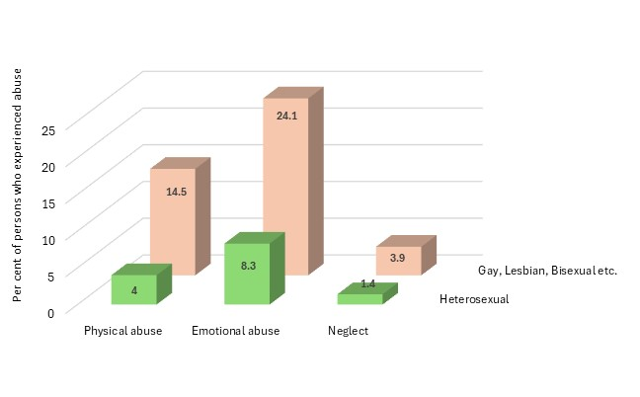

Proportion of disabled persons aged 18 years or more, who had experienced abuse, by sexual orientation and type of abuse: Australia, 2022